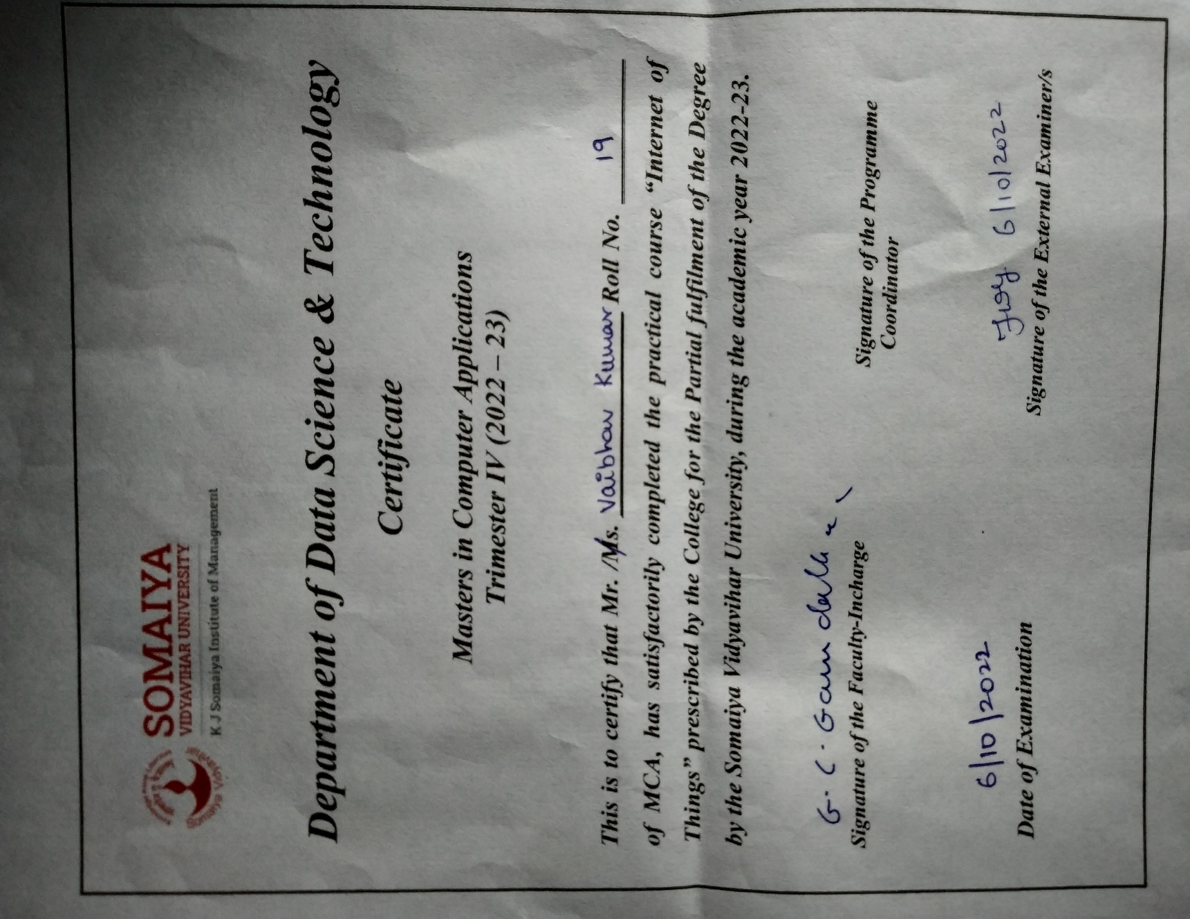

|  |  |  |
| --- | --- | --- |
| **SrNo** | **Practical** | **Page No** |
| 1 | CCS Installation, User Interface tour, Project creation, Compiling and debugging with MSP432 | 1-18 |
| 2 | Hello world of Embedded Systems | 19-27 |
| 3 | Installing Node.js, Node-Red and Node Red interface. | 28-35 |
| 4 | Introducing the inject, function, debug and switch nodes | 36-38 |
| 5 | Random number generation with selection of color. Introducing the HTTP node. | 39-42 |
| 6 | CPU utilization flow. | 43-44 |
| 7 | WiFi Setup | 45-50 |
| 8 | Analog to Digital Converter | 51-57 |
| 9 | Sending Raw Data to the Cloud | 58-70 |
| 10 | Connecting MSP432 to the Cloud | 71-82 |

# **Practical 1**

**Practical Name: CCS Installation, User Interface tour, Project creation, Compiling and debugging with MSP432**

**CCS INSTALLATION:**

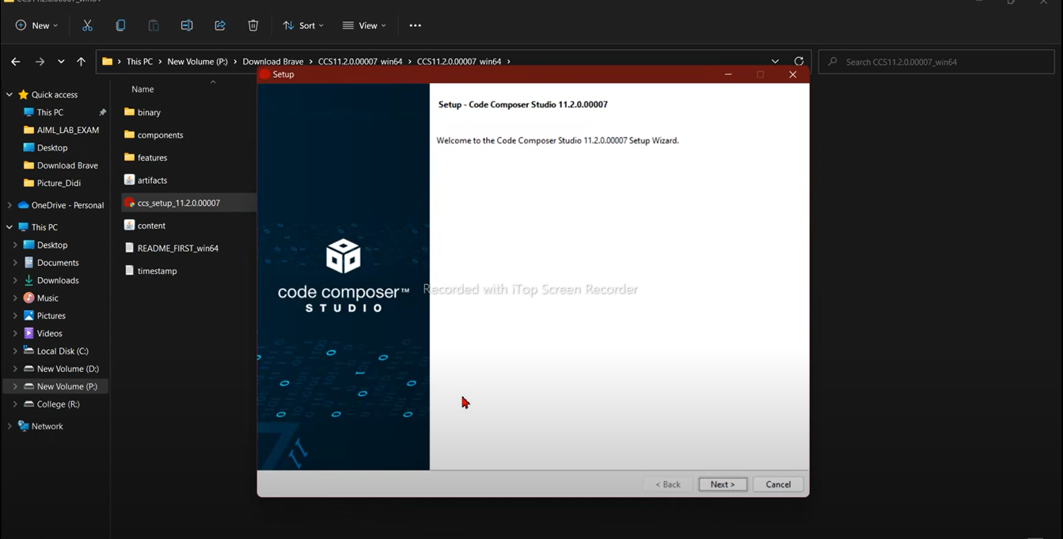

# 

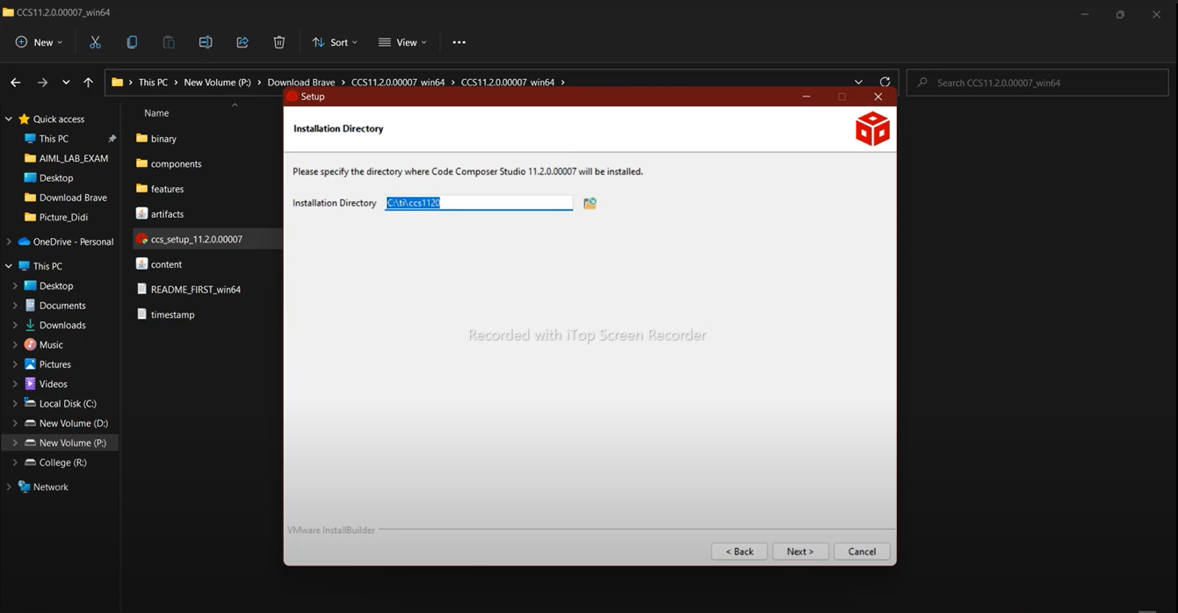

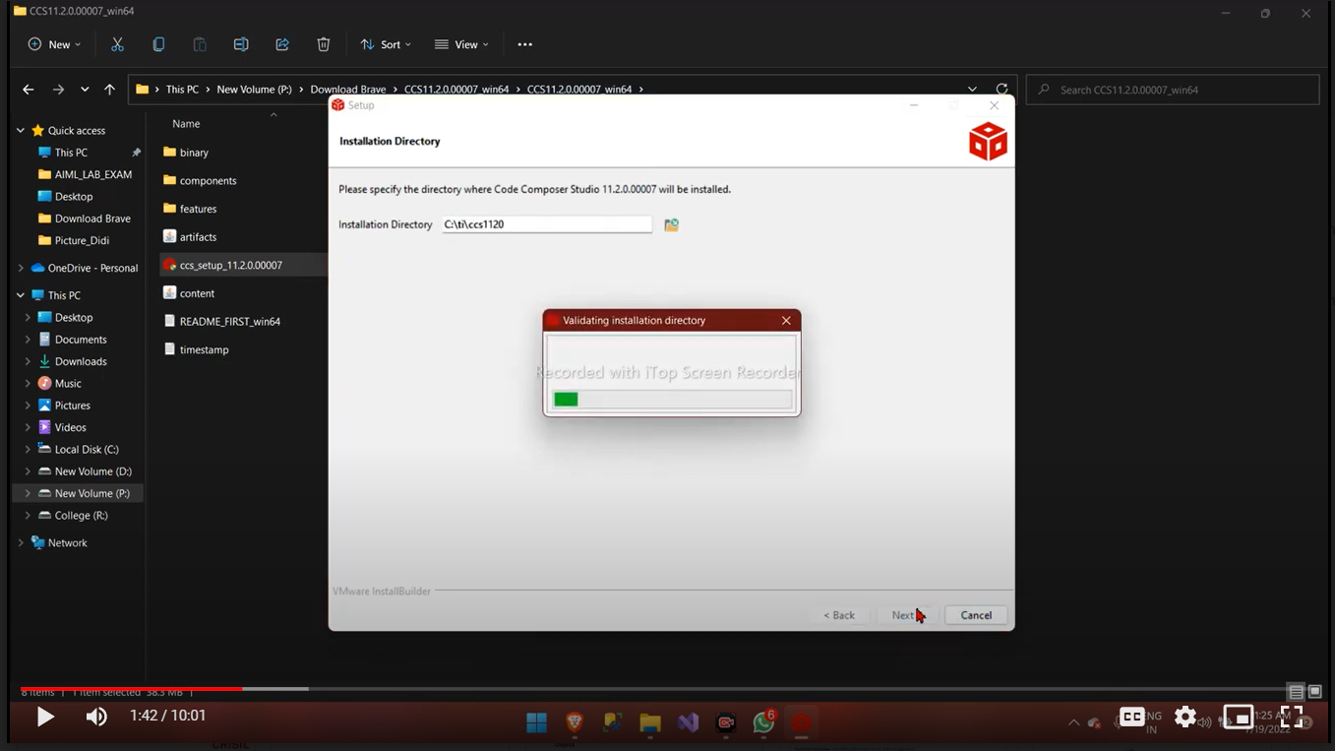

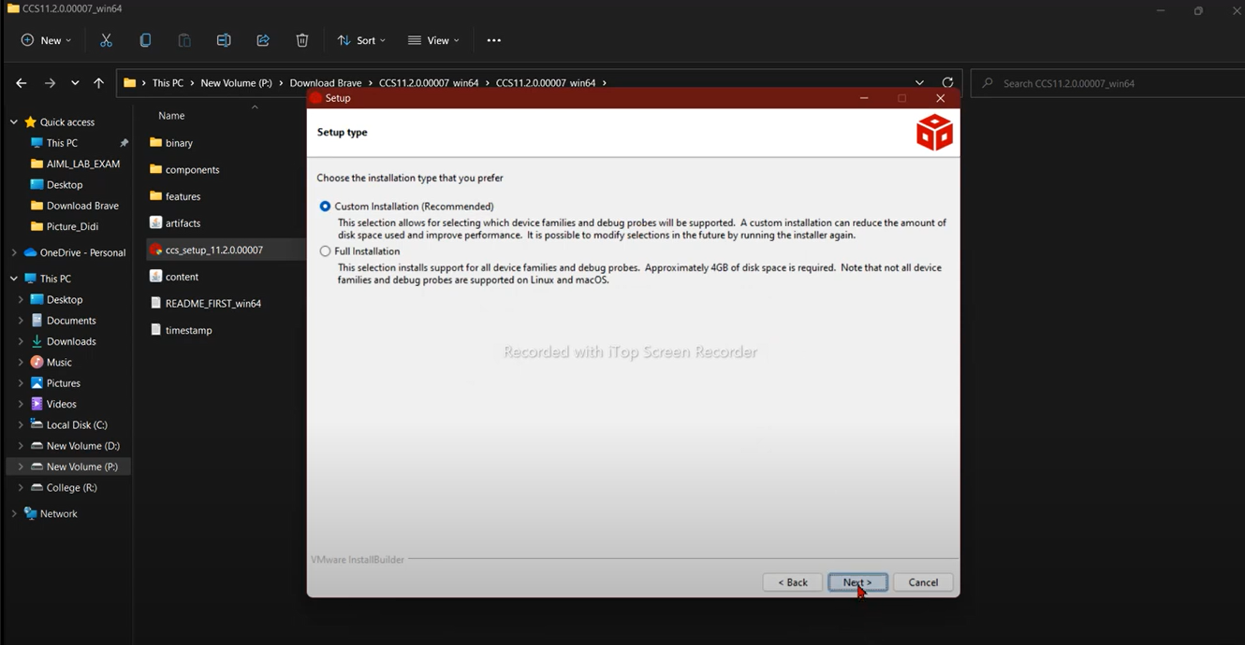

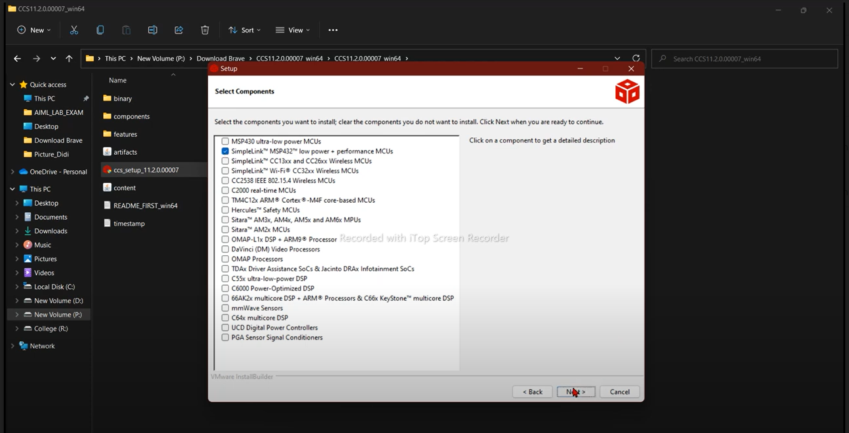

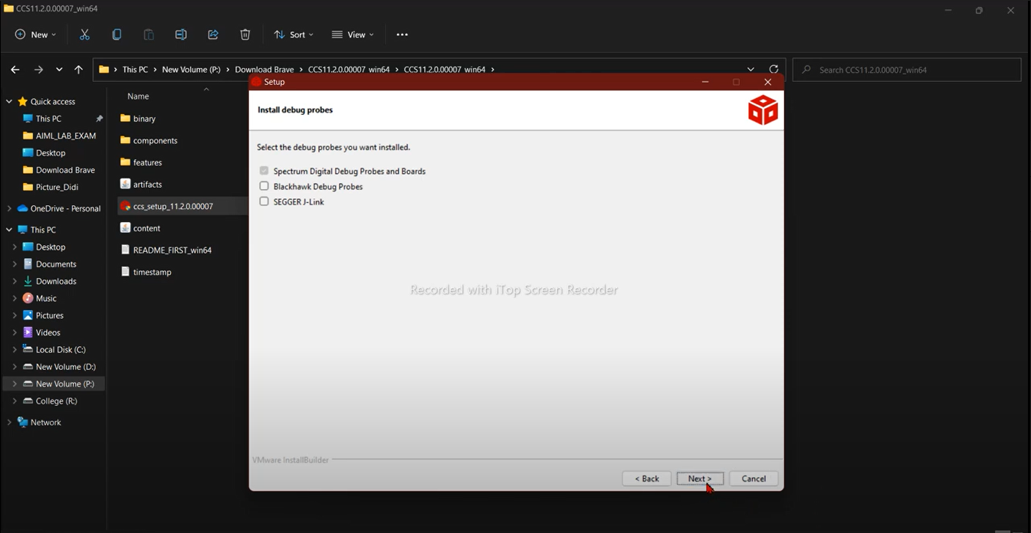

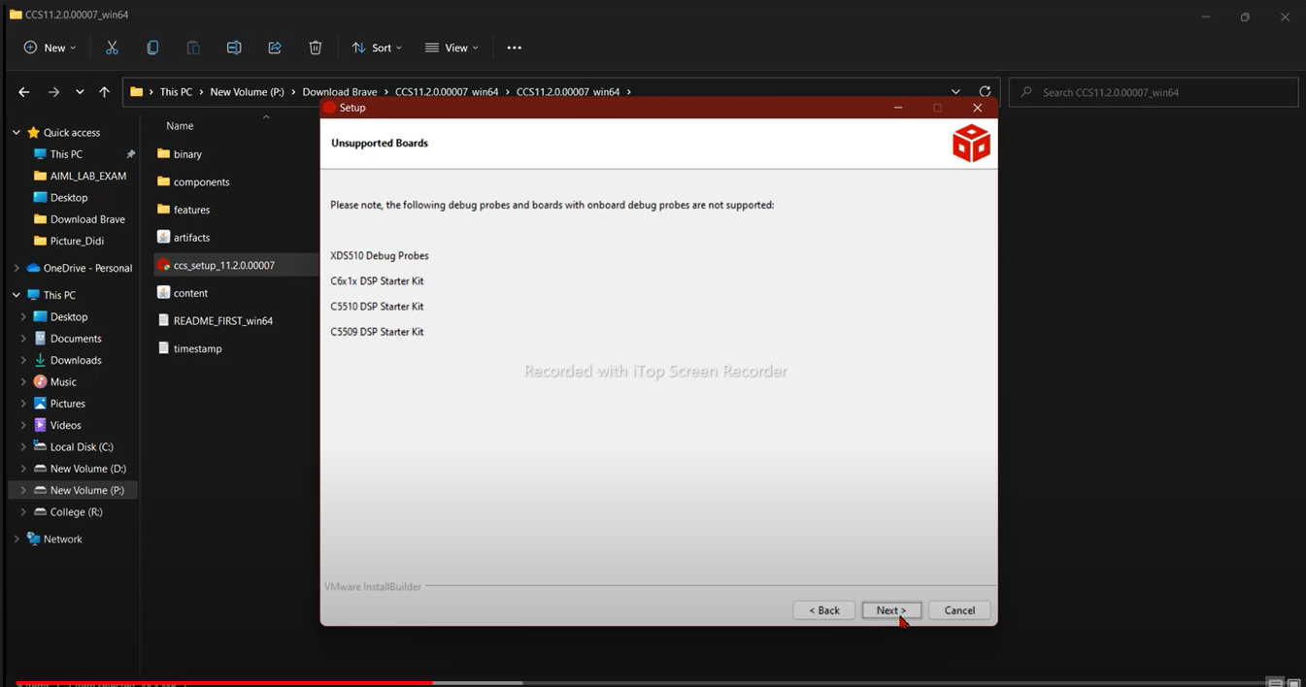

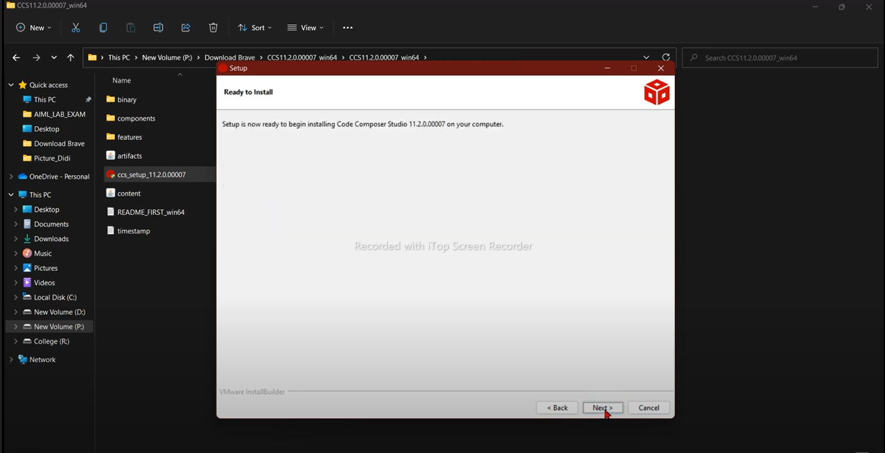

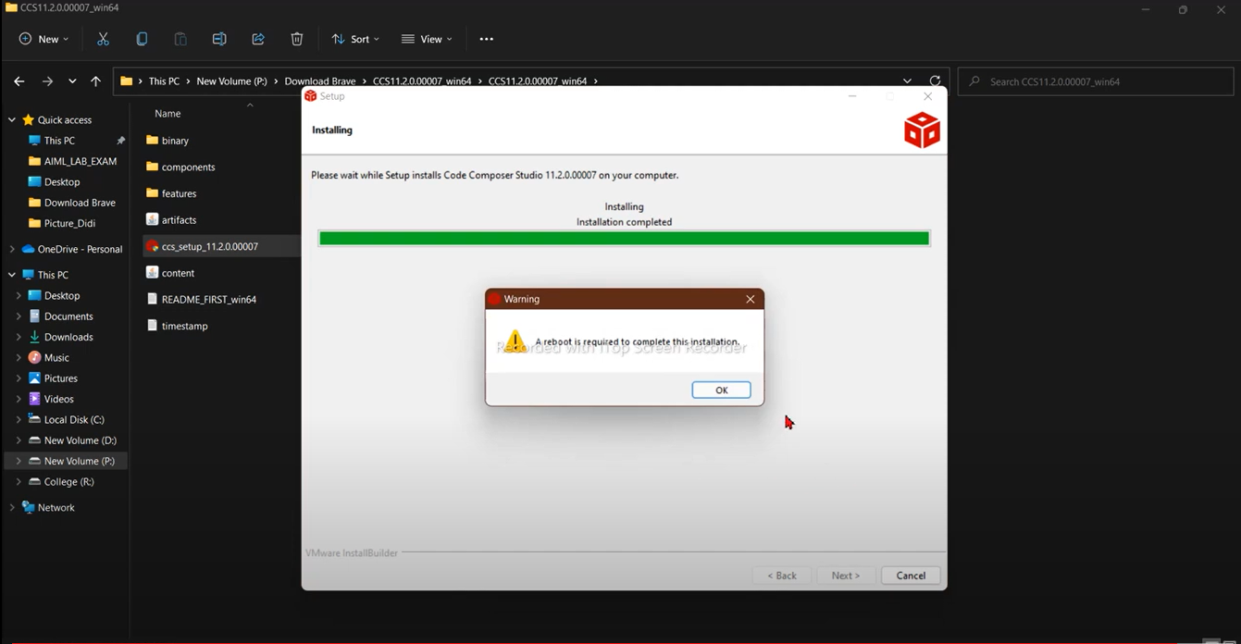

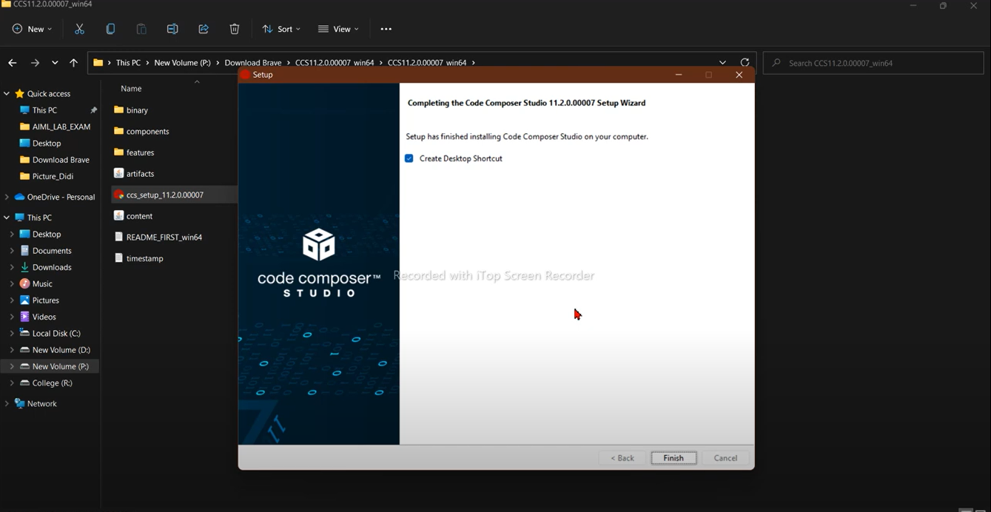

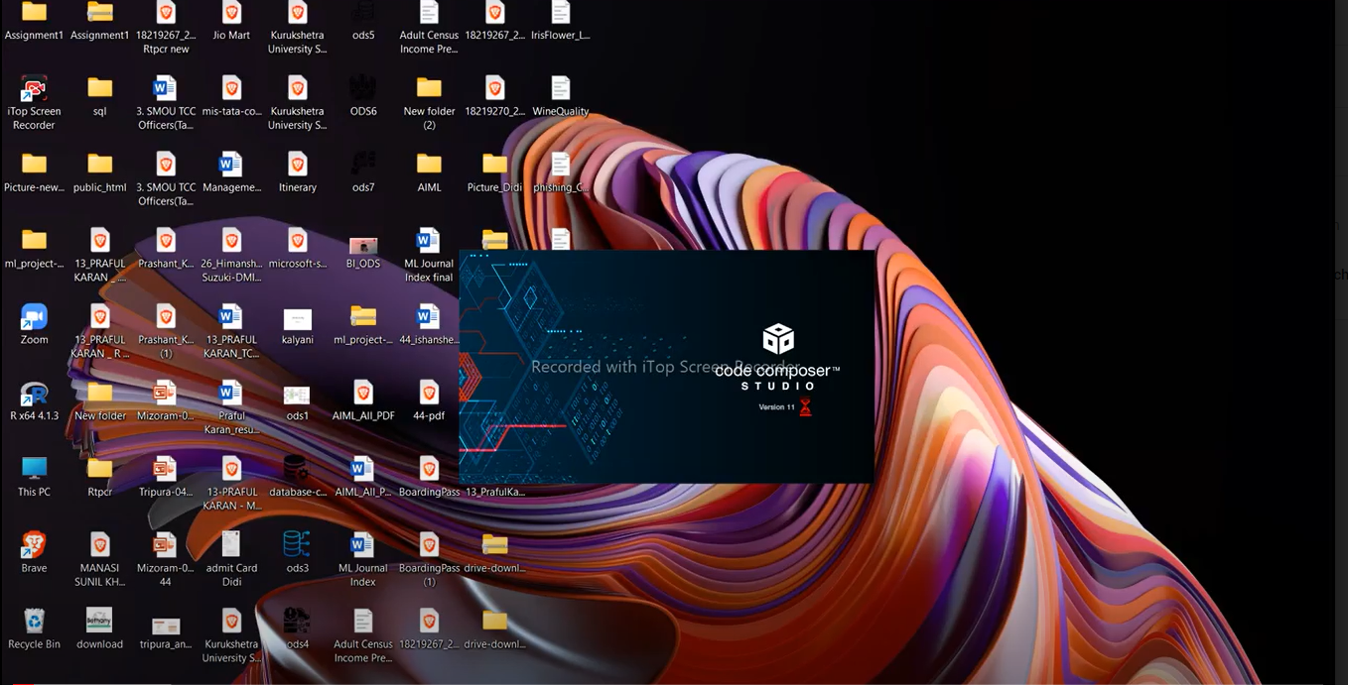

**MSP432 SDK INSTALLATION**

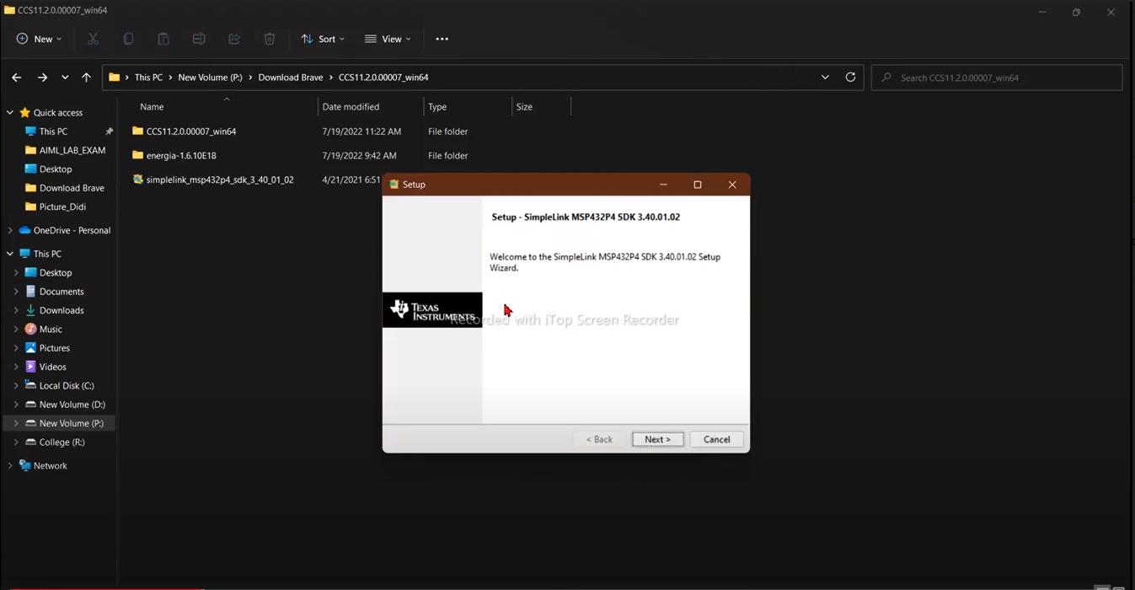

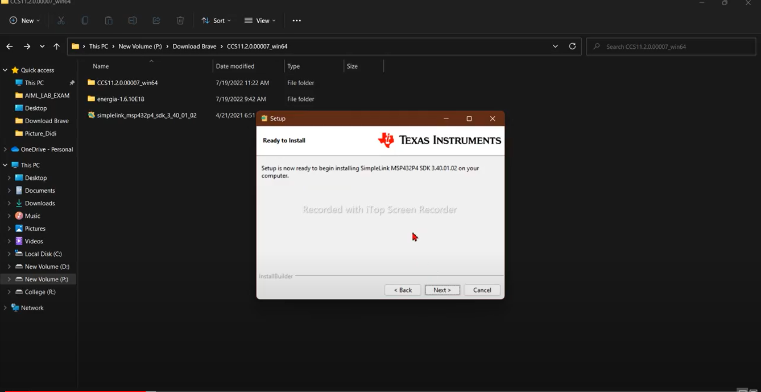

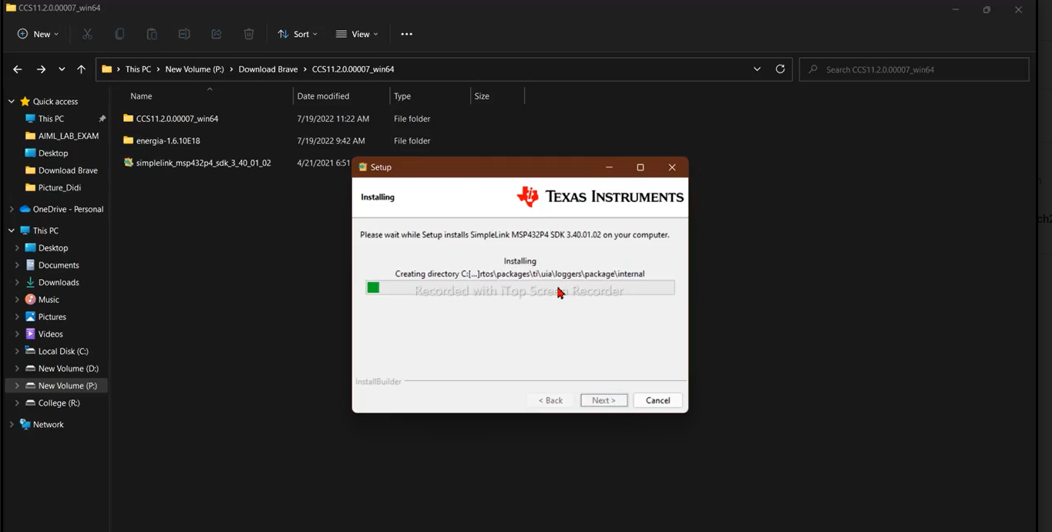

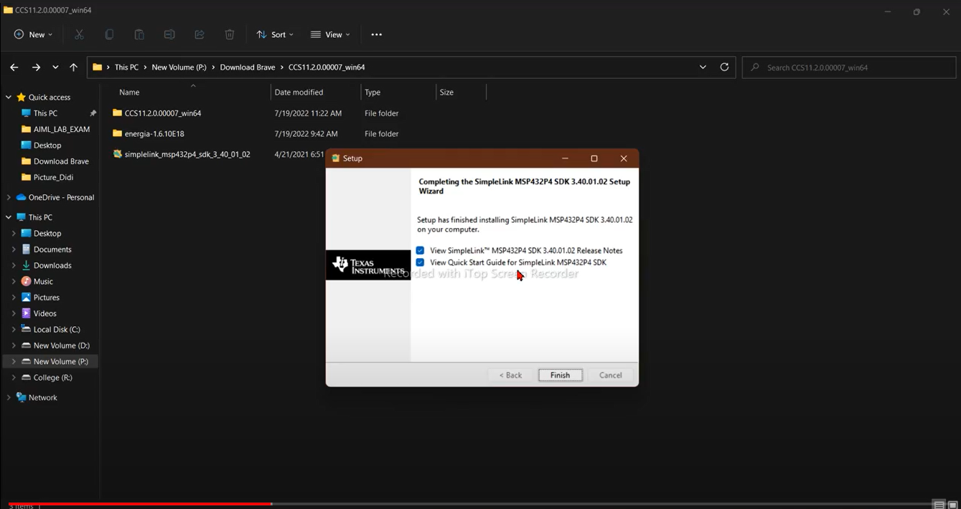

**ENERGIA INSTALLATION WITH BOARD MANAGER DETAILS:**

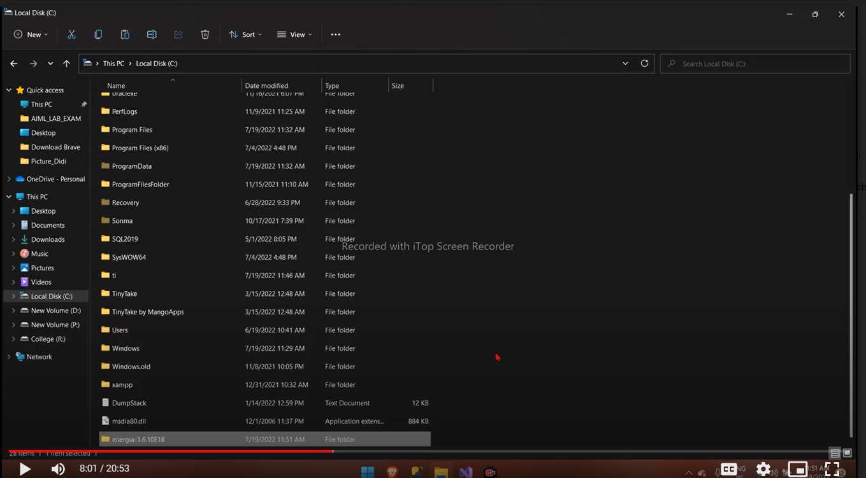

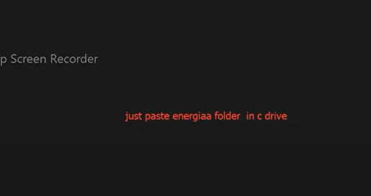

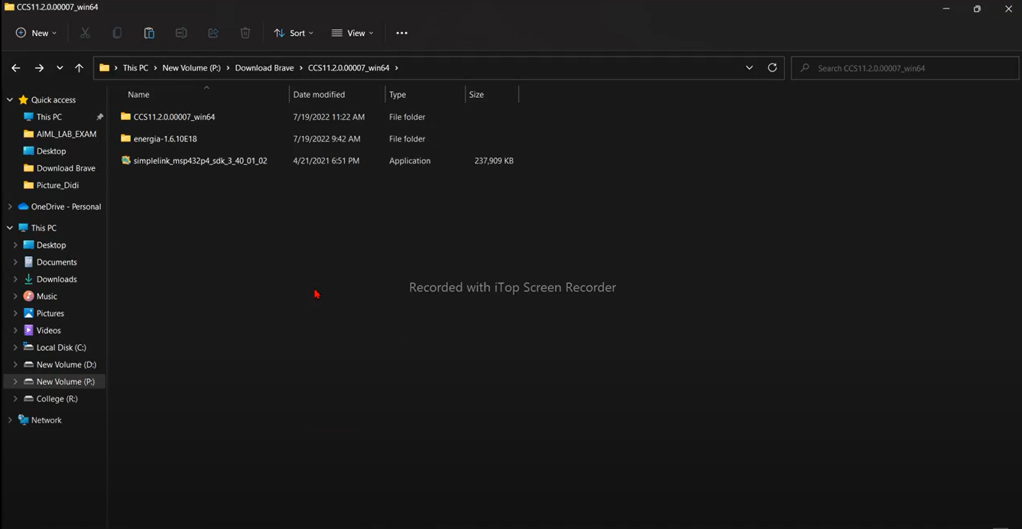

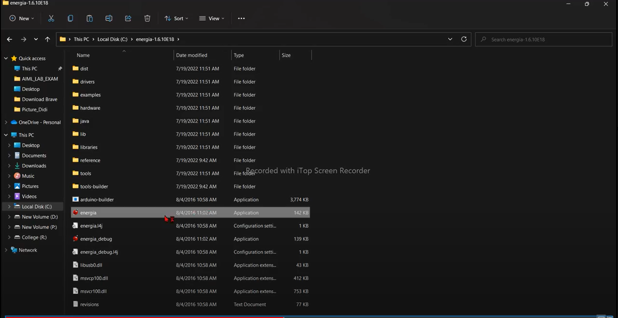



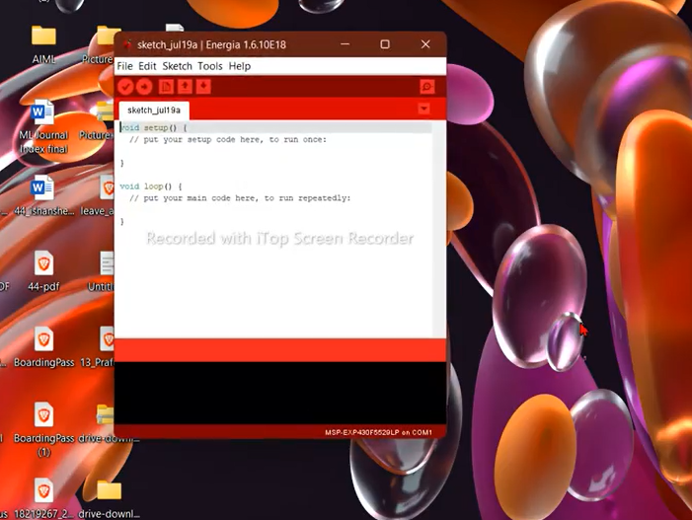

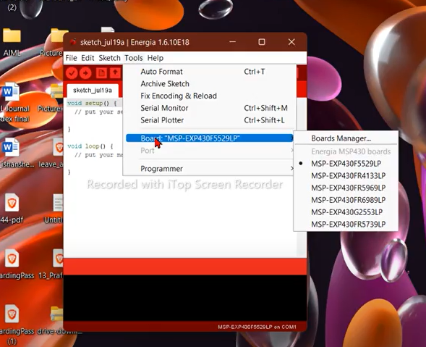

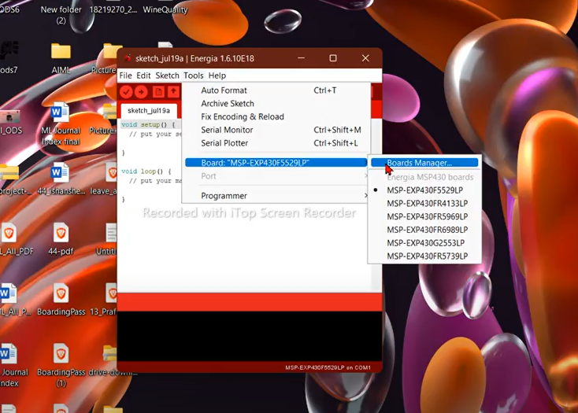

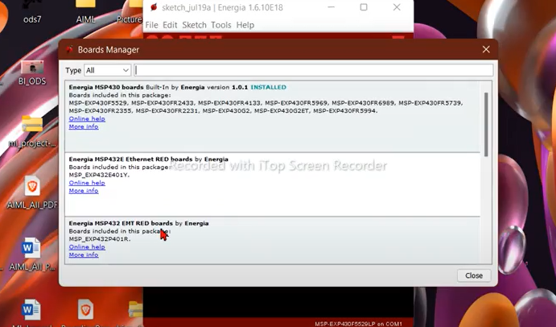

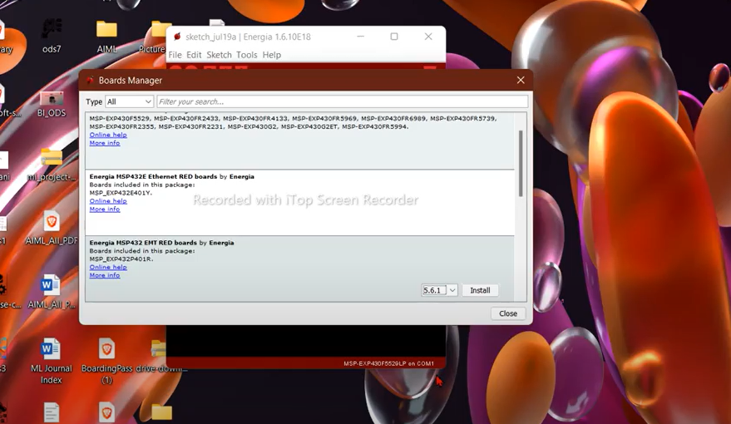

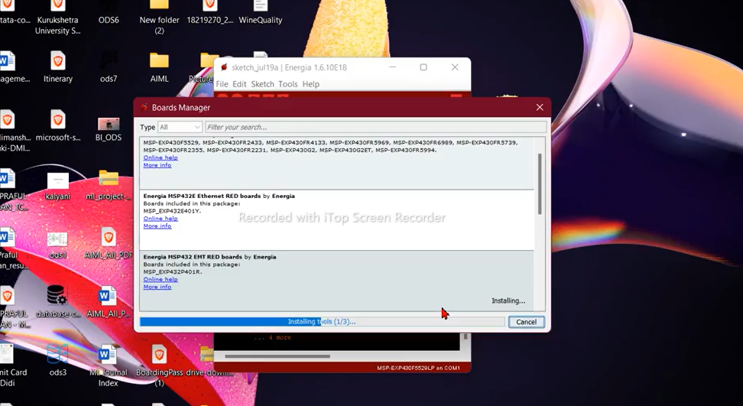

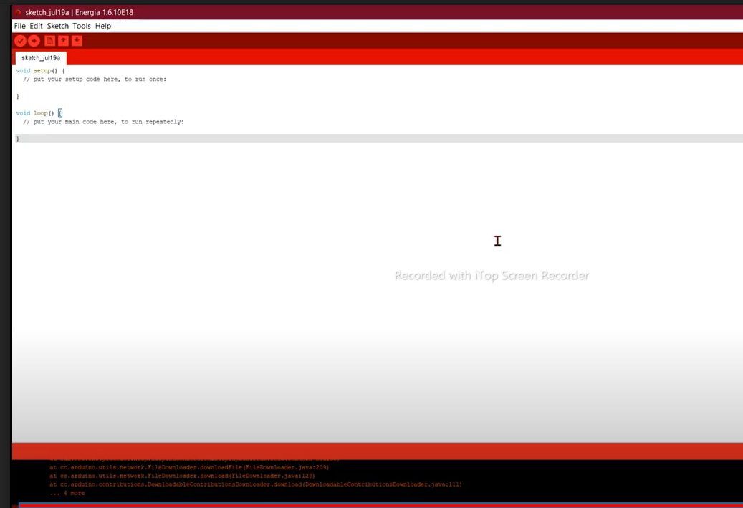

# **Practical 2**

**Practical Name: Hello world of Embedded Systems**

Open Code Composer Studio Launcher

Keep the workspace path bydefault

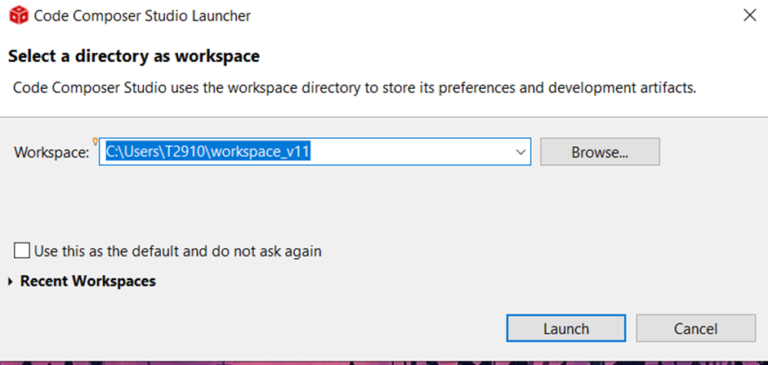

Select the Project Menu->Import CCS Project

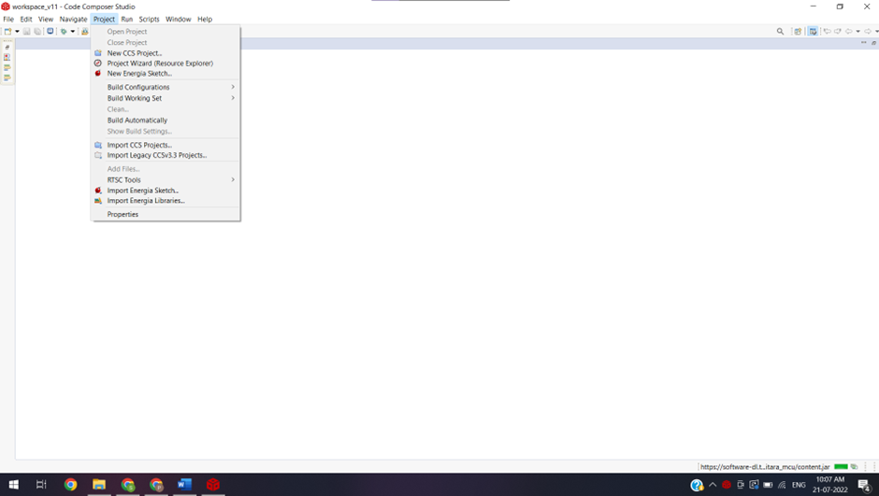

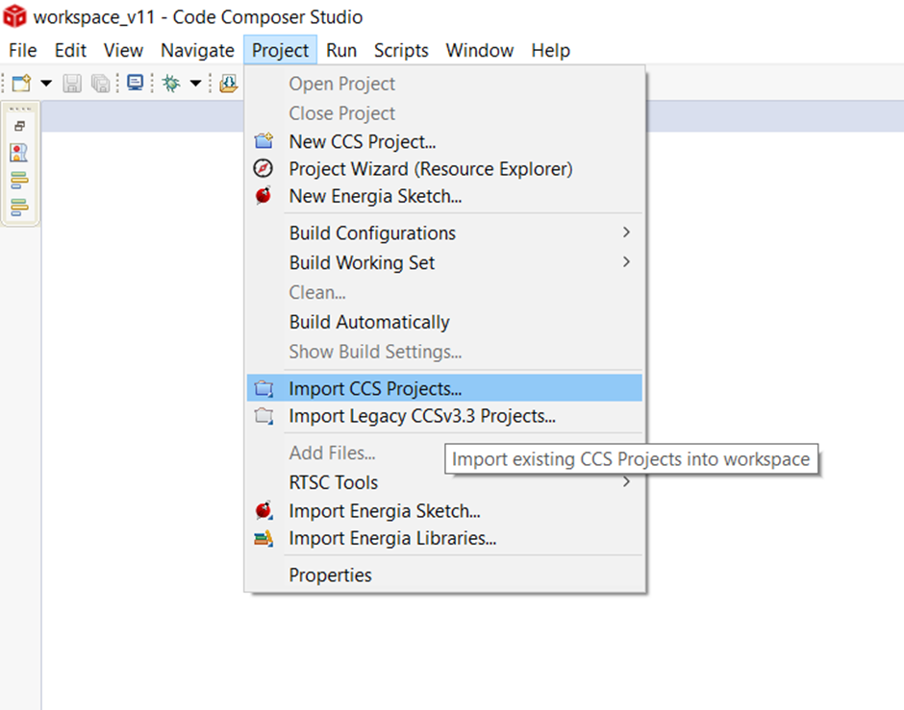

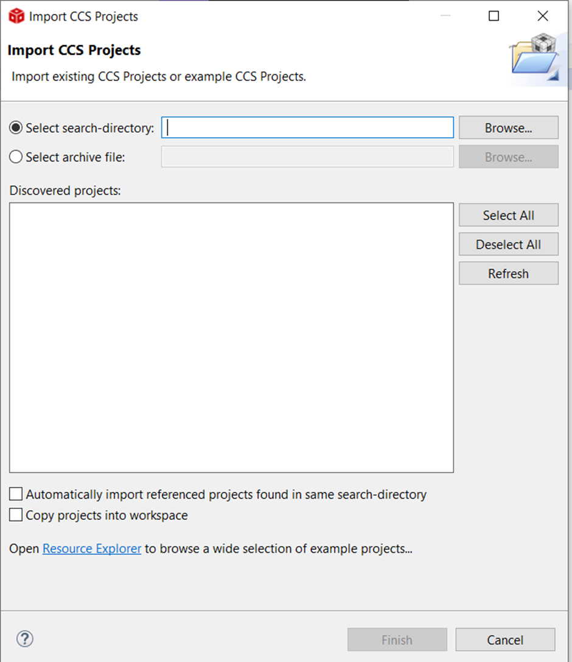

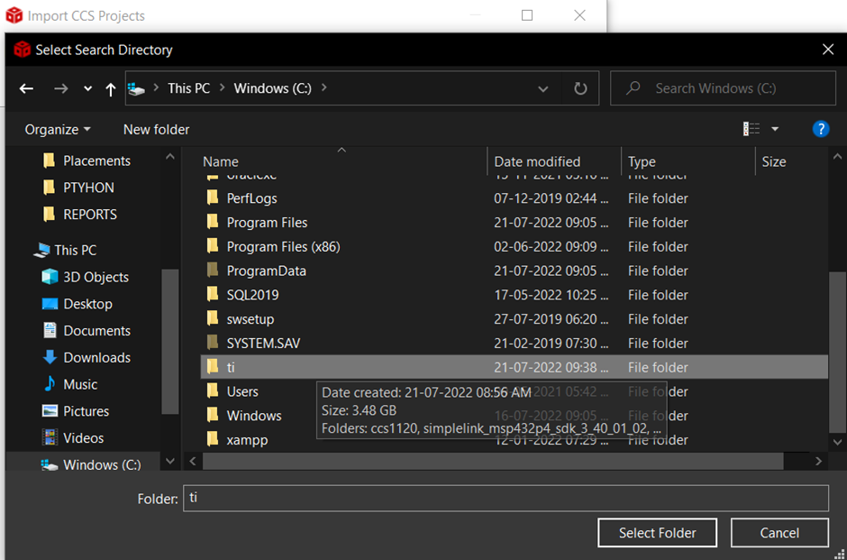

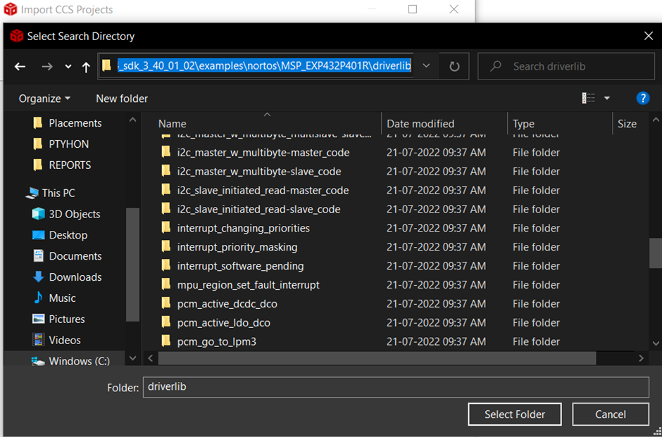

**Path:C:\ti\simplelink_msp432p4_sdk_3_40_01_02\examples\nortos\MSP_EXP432P401R\driverlib**

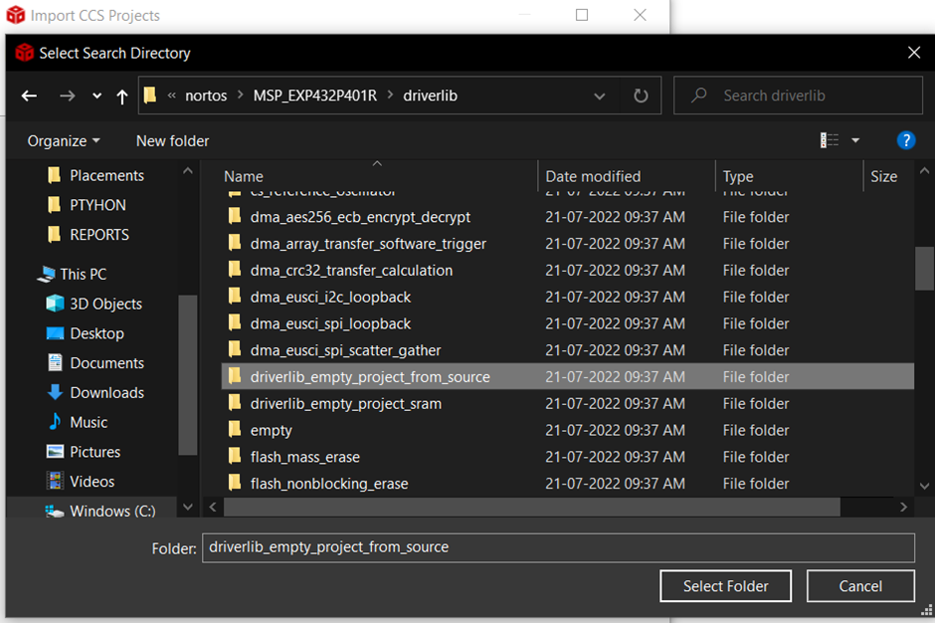

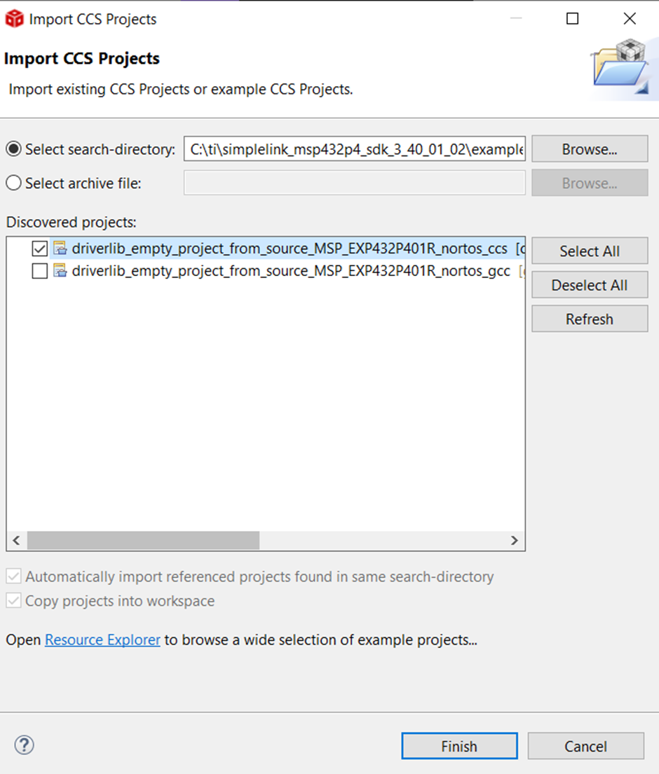

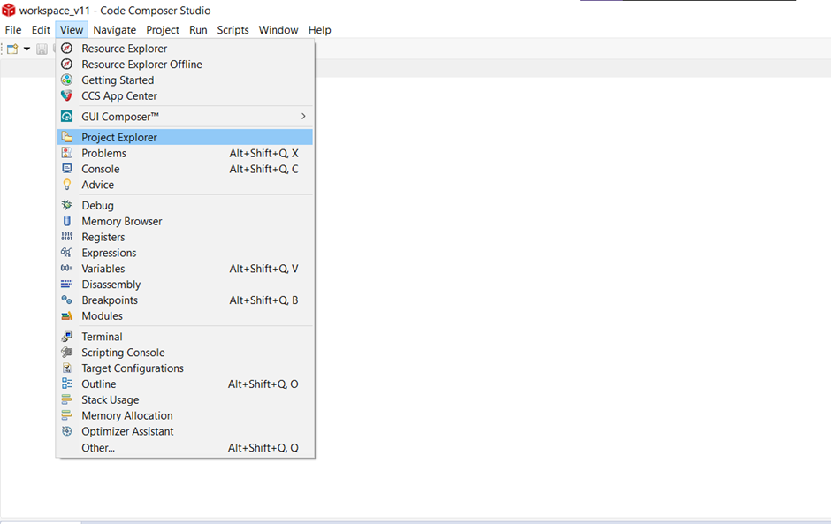

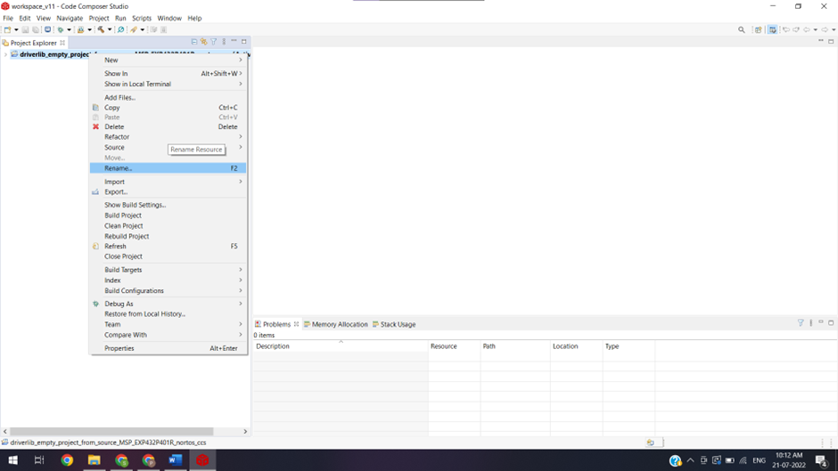

Give Project Name HELLO WORLD

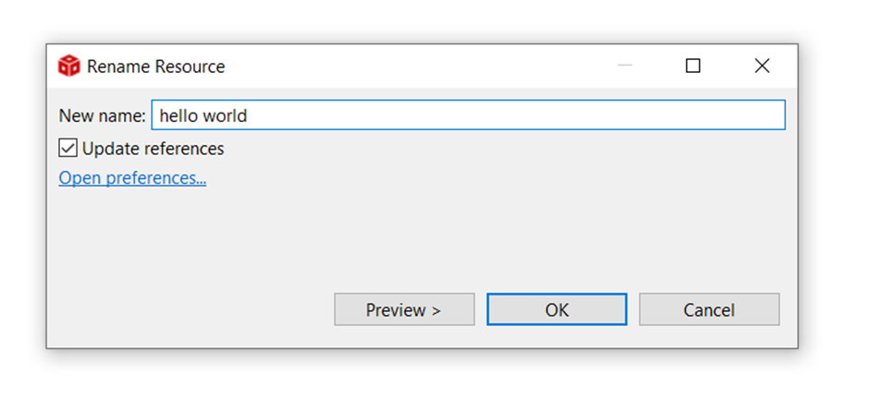

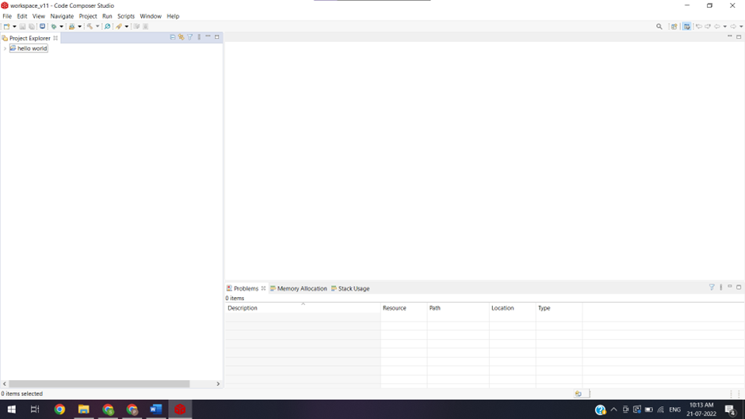

/* DriverLib Includes */

#include <ti/devices/msp432p4xx/driverlib/driverlib.h>

/* Standard Includes */

#include <stdint.h>

#include <stdbool.h>

int main(void)

{

/* Stop Watchdog */

MAP_WDT_A_holdTimer();//watch dog timer , this timer starts when kit is given power

// if it stops it will cause kit to reset

int i;

GPIO_setAsOutputPin(GPIO_PORT_P2,GPIO_PIN0);

**// port is combination of 8 pins 0-7 , means 8 bits , 8 bits forms a port**

**// this MC has 10 ports**

**// this func tells mc to make PORT2, pin 0 as OUTPUT pin**

**// GPIO means general purpose input output**

while(1) **// super loop**

{

GPIO_setOutputHighOnPin(GPIO_PORT_P2,GPIO_PIN0);**//setting the pin as HIGH**

for(i=0;i<10000;i++); **// random delay**

GPIO_setOutputLowOnPin(GPIO_PORT_P2,GPIO_PIN0);**//setting the pin as LOW**

for(i=0;i<100000;i++); **//random delay**

}

}

# **Practical 3**

**Practical Name: Installing Node.js, Node-Red and Node Red interface.**

Visit the URL: <https://nodejs.org/en/>

Download the nodejs for Windows(x64)

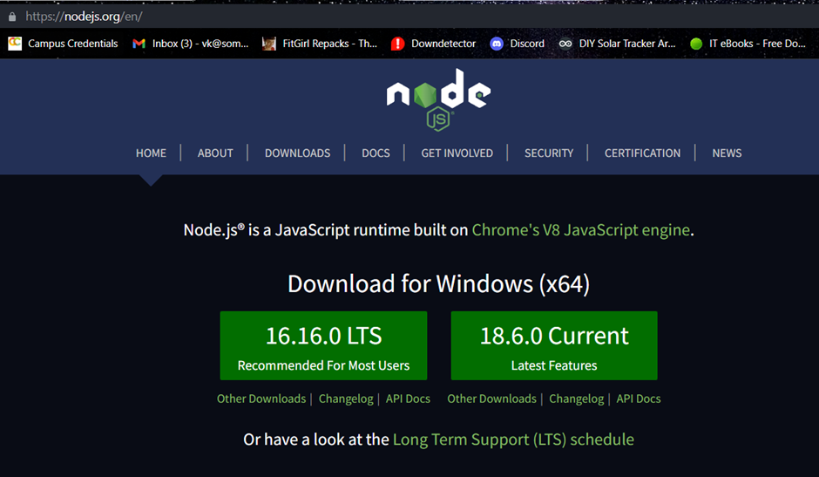

Open the Command Prompt

Enter the following commands to install Node.js

Node - - version

Install g - -unsafe-perm node-red

npm - -version

npm cache clean - -force

node -v

node -red

Then open the browser and start node red at the port 1880 and put the screen shot of the same with the URL used in the web browser.

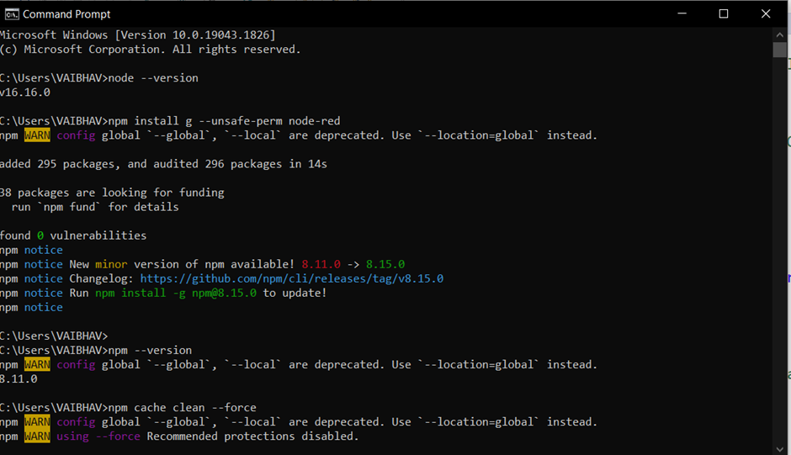

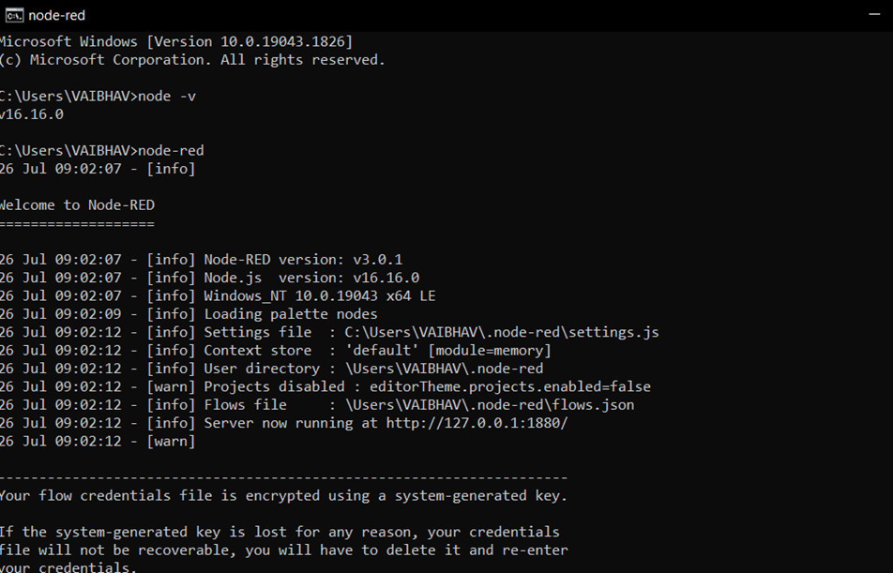

Then open the browser and start node red at the port 1880

https://127.0.0.1:1880/

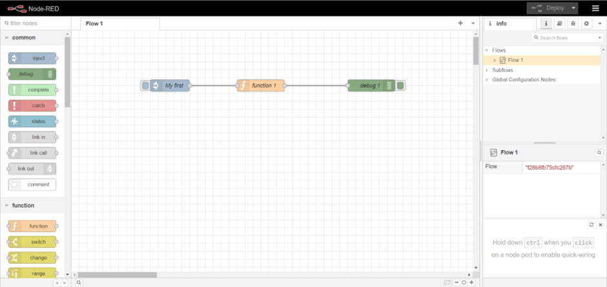

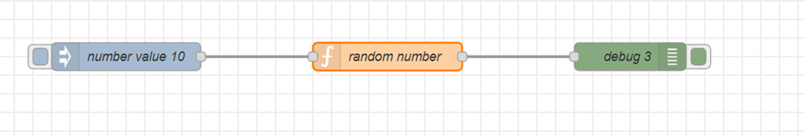

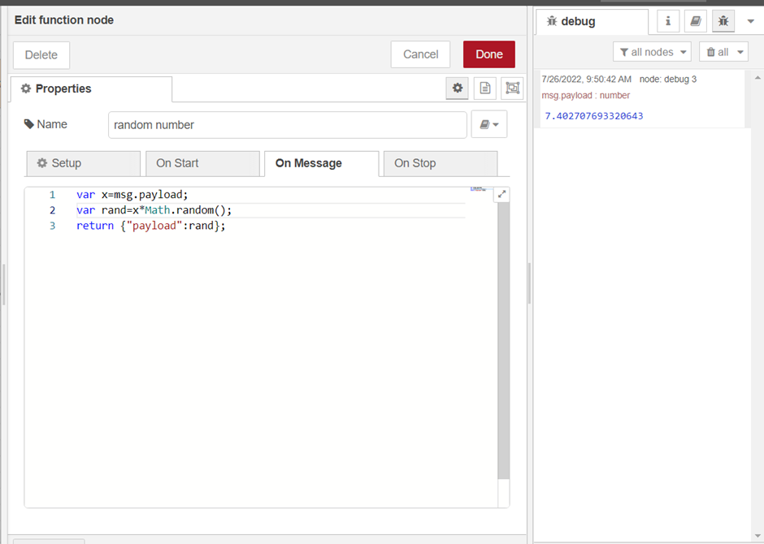

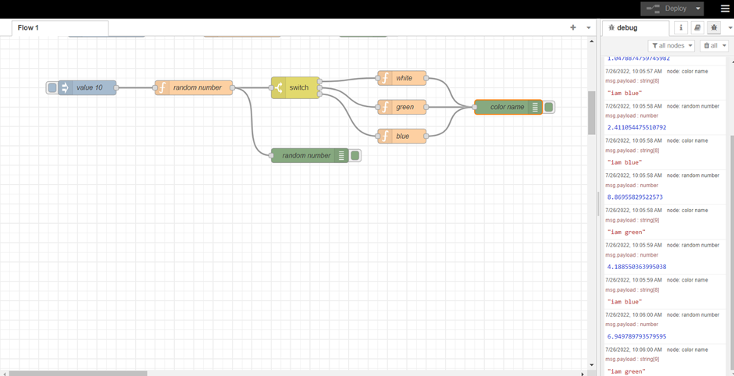

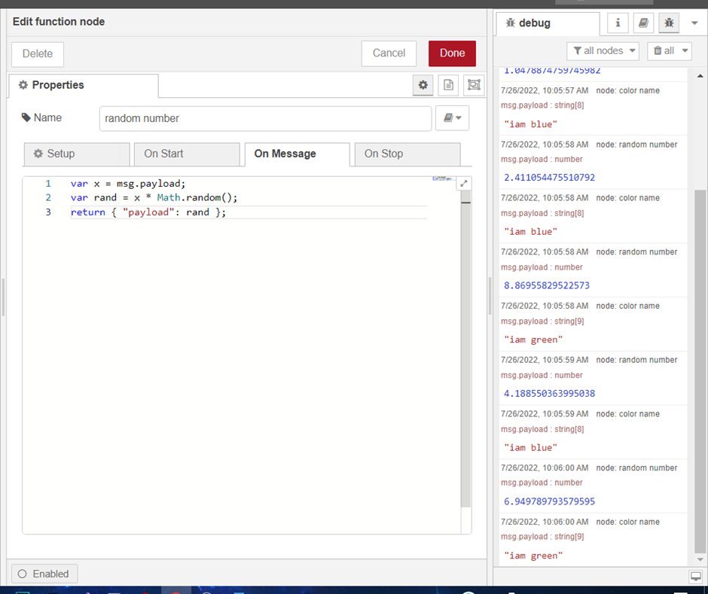Install pallet

node-red-contrib-cpu

Node-red-dashboard

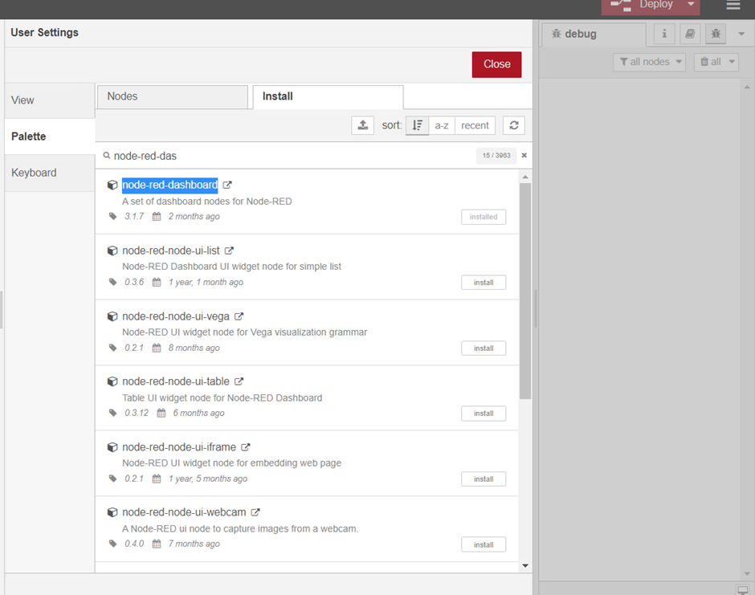

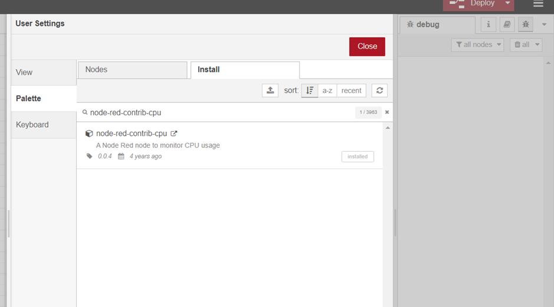

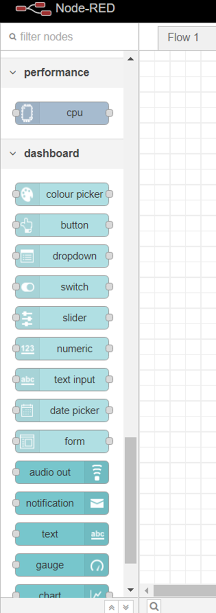

**Practical 4**

**Practical Name: Introducing the inject, function, debug and switch nodes.**

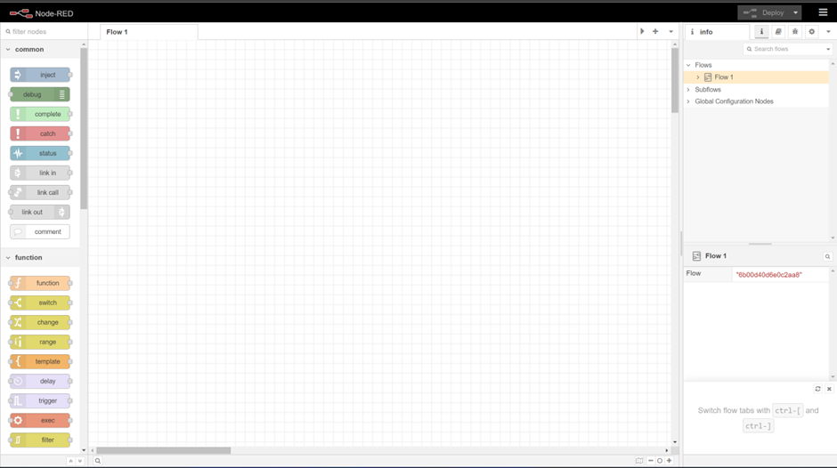

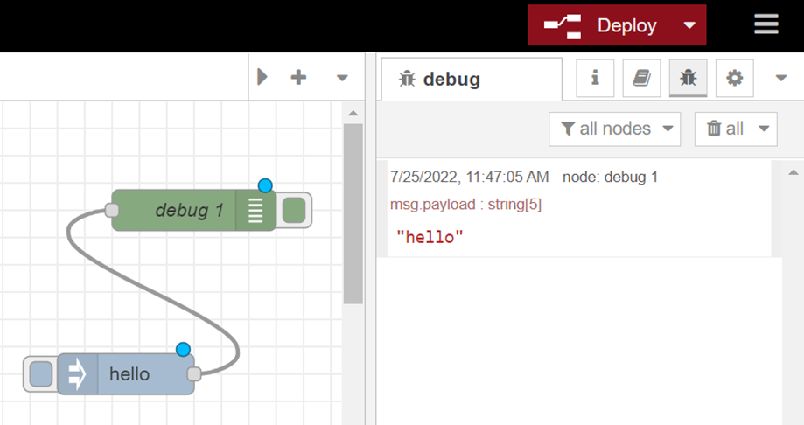

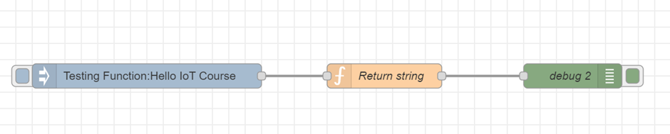

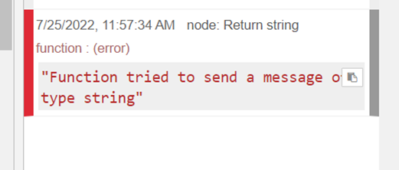

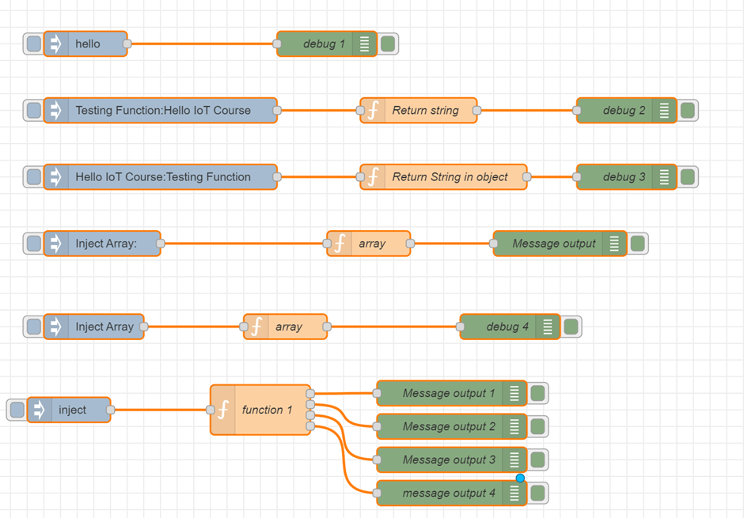

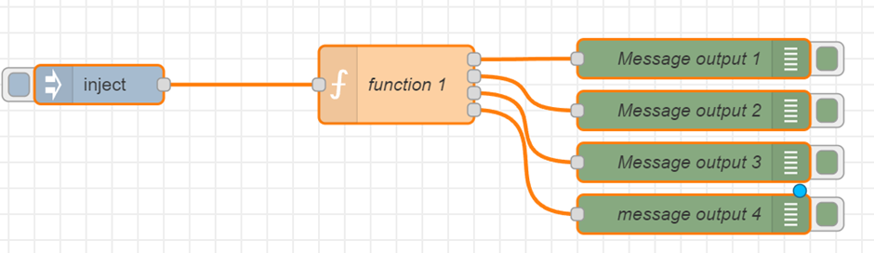

**Practical 5**

**Practical Name: Random number generator with selection of color. Introducing the HTTP node.**

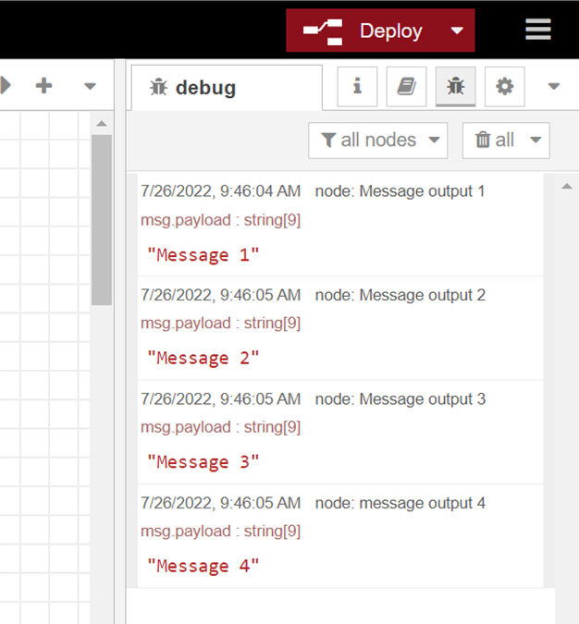

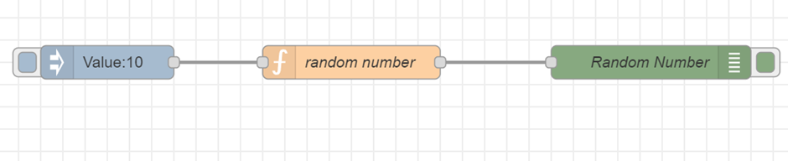

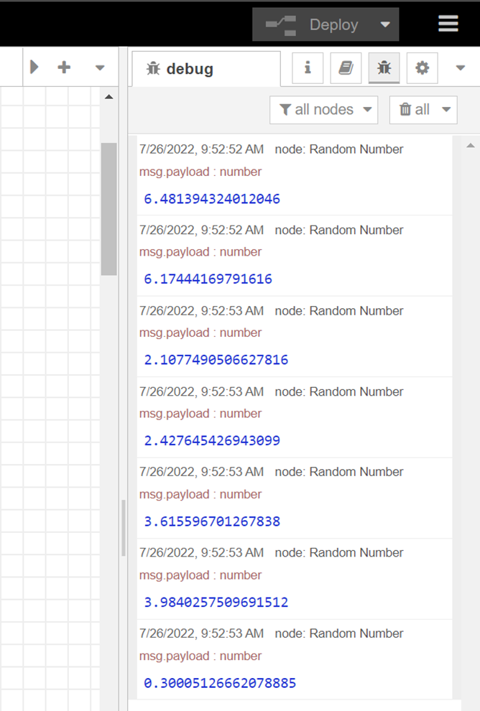

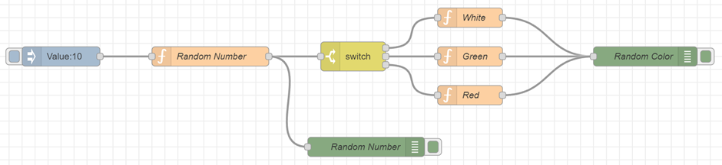

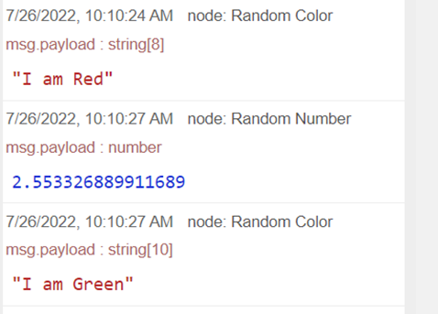

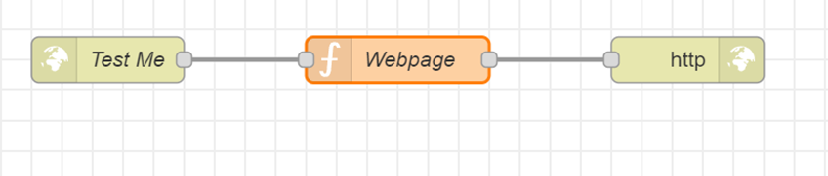

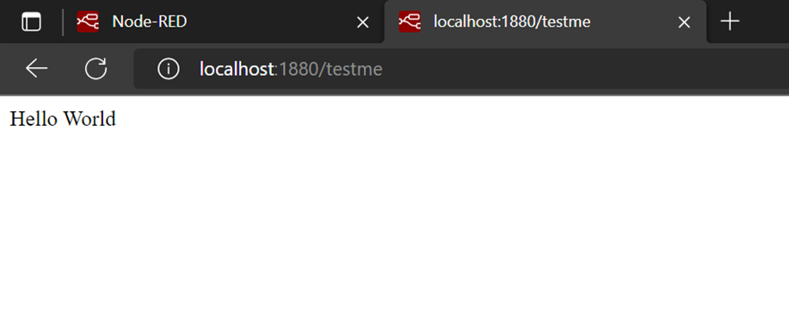

## **Practical 6**

## **Practical Name: CPU utilization flow.**

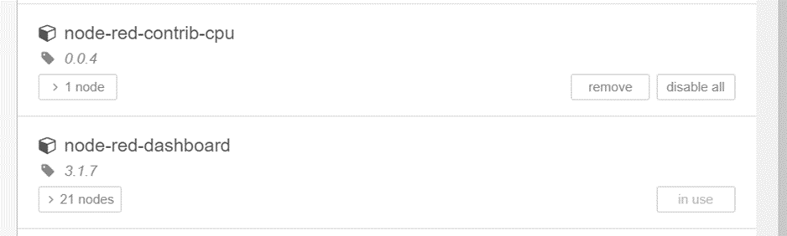

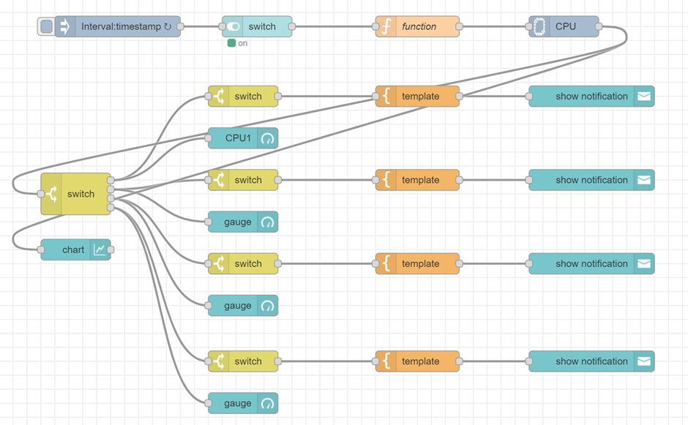

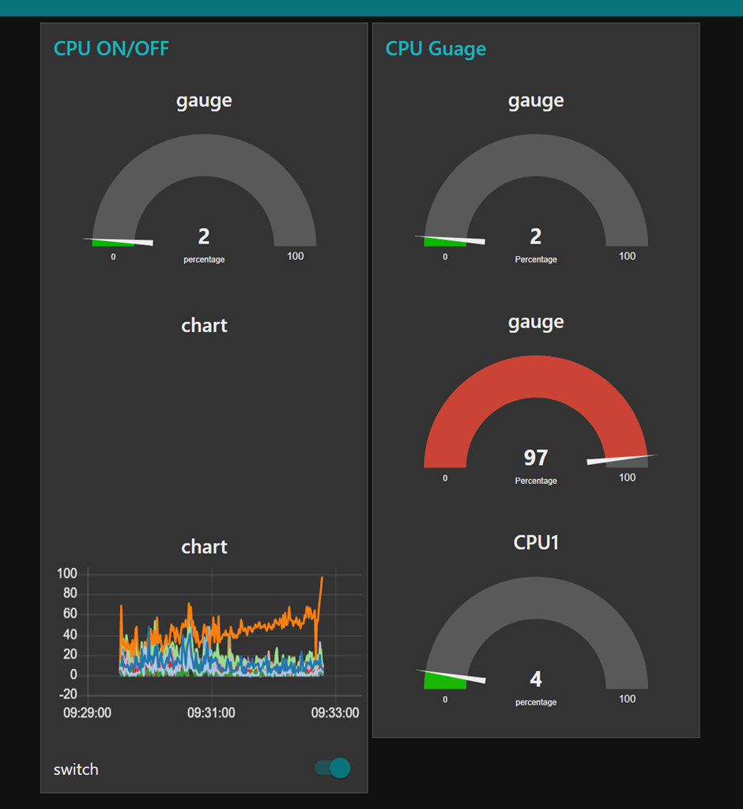

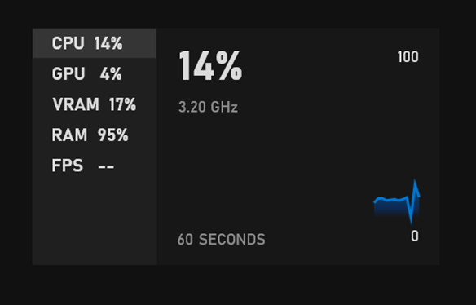

# **Practical 7**

**Practical Name: WiFi Setup**

Create a project

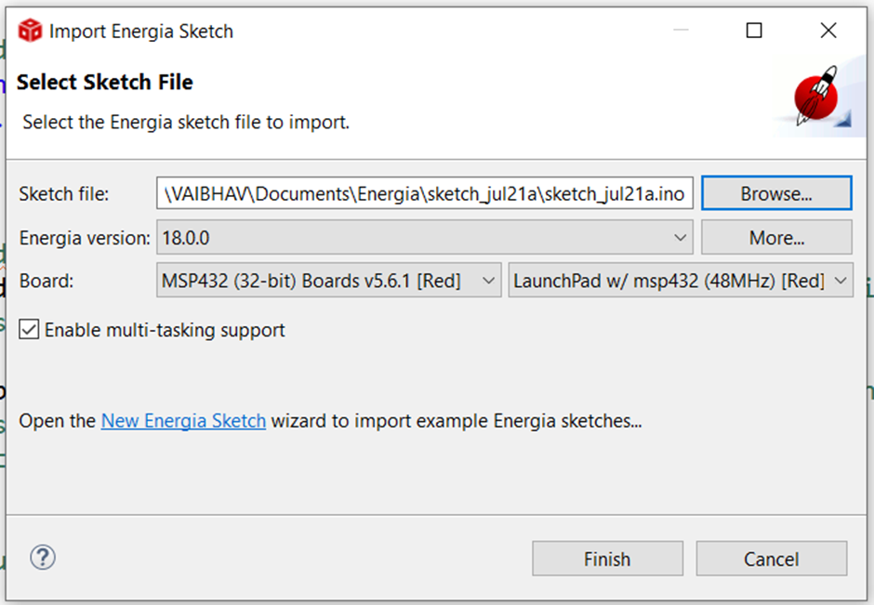

**Write the code in Energia Sketch and save the file**

**sketch_jul21a.ion**

#include <WiFi.h>

#include <SPI.h>

void setup() {

// put your setup code here, to run once:

}

void loop() {

// put your main code here, to run repeatedly:

}

**main.css**

#include <WiFi.h>

#include <SPI.h>

//#define SSID "octanauts"

//#define PASSWORD "aditya30"

IPAddress shieldIP,subnetMask,gatewayIP; //IPAddress is a datatype , all others are variables of type IPAddres uint8_t rssi;//unsigned interger of 8 bits

uint8_t networkId;

byte macAddr[6];// mac address is 6 bytes // physical address of device is mac add

byte encryptionType;

//char ssid[]="vivoY73";// my cell phone

char ssid[]="VK";

/*

char ssid[]="vK";

char password[]="";

*/

void setup() {

**// put your setup code here, to run once:**

Serial.begin(115200);//Serial is class and begin is method all present in SPI library

**//putty is a terminal emulator**

**//it will connnect the port and device at a given speed**

Serial.print("connecting to WIFI..");

while(WiFi.begin(ssid)!=WL_CONNECTED)//for cell phone //WL_CONNECTED while it is not connected

//while(WiFi.begin(ssid.password)!=WL_CONNECTED)

{

Serial.print(".");

delay(1);

}

Serial.println("");

Serial.print("Wifi Connected , Fetching Wifi Sheild's IP address :");

while(WiFi.localIP()==INADDR_NONE){

Serial.print(".");

delay(1);

}

shieldIP = WiFi.localIP();**//WIFI Method , local IP takes IP address and stores in var in IPADRESS DATATYPE**

Serial.println(shieldIP);

Serial.print("Access Point name:");

Serial.println(ssid);

Serial.print("Signal Strength");//

rssi=WiFi.RSSI();**//it fecthes the signal strength**

Serial.println(rssi); **//RSSI-Recived signal strength indication**

uint8_t networkId= WiFi.scanNetworks();

Serial.print("number of access points in range:");

Serial.println(networkId);

for(int i=1;i<=networkId;i++){

Serial.print("Name of Access points and encryption type:");

Serial.print(WiFi.SSID(i));

Serial.print(",");

encryptionType=WiFi.encryptionType(i);

//Serial.println(encryptionType,HEX);

Serial.println(encryptionType,DEC);

}

subnetMask = WiFi.subnetMask();

Serial.print("Subnet Mask:");

Serial.println(subnetMask);

gatewayIP=WiFi.gatewayIP();

Serial.print("Gateway IP Address:");

Serial.println(gatewayIP);

WiFi.macAddress(macAddr);

Serial.print("Mac Address of Sheild:");

for(int i=0;i<6;i++){

Serial.print(macAddr[i],HEX);

if(i<=4)

Serial.print(':');

else

Serial.println();

}

}

void loop() {

**// put your main code here, to run repeatedly:**

}

**Putty terminal** is need to connect the port and device at given speed.

**Setting up the putty configuration:**

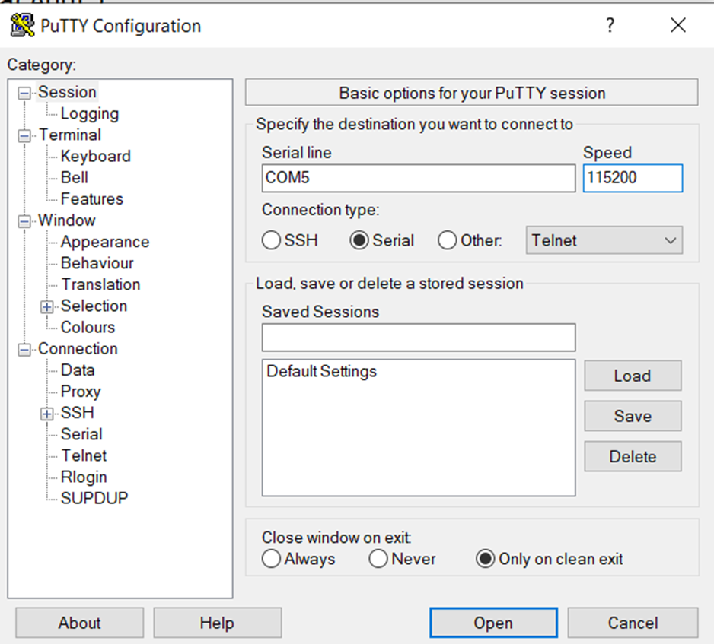

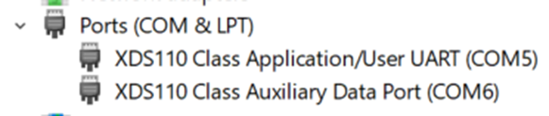

**Output:**

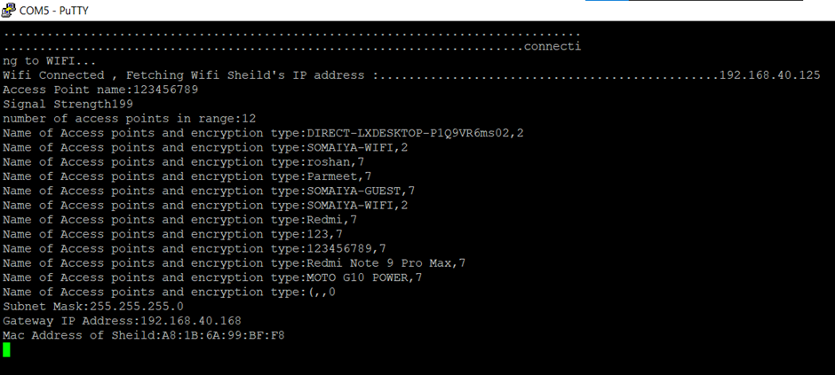

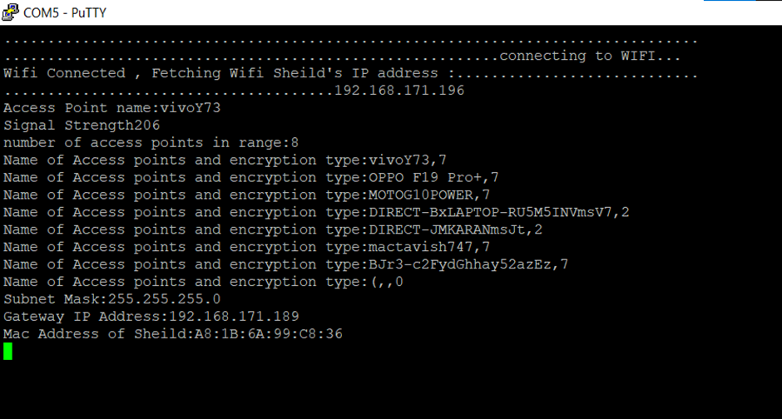

# **Practical 8**

**Practical Name: Analog To Digital Converter**

**1)Explain the ADC properties:**

Analog to Digital Converter (ADC) is an electronic integrated circuit used to convert the analog signals such as voltages to digital or binary form consisting of 1s and 0s. Most of the ADCs take a voltage input as 0 to 10V, -5V to +5V, etc., and correspondingly produces digital output as some sort of a binary number.

Main features of ADC are:

* The sample rate of an ADC is nothing but how fast an ADC can convert the signal from analog to digital.
* Bit resolution is nothing but how much accuracy can an analog to digital converter can convert the signal from analog to digital

**2)Explain the API used for configuring the ADC:**

***1)GPIO_setAsOutputPin():*** Its NOT a digital OR operator,we want to use all 3 pins thats why we used Pipe operator GPIO_setAsPeripheralModuleFunctionInputPin() : potentiometer is connect in port 4 ,pin 7 becoz ADC exists in PIN 7 of port 4 and then digital signal goes to LED

***2)ADC14_initModule() :*** It is called first to initialize the ADC14 module with the desired ADC14 clock, clock predivder and clock divider. ADC Noroute parameter means no internal analog source is user for the conversion.

***3)ADC14_configureSingleSampleMode(ADC_MEM6,true) :*** It is executed with ADC_MEM6 as the target conversion memory register for input channel A6.The true boolean means that this single conversion is a repeat-signal-mode

***4)ADC14_configureConversionMemory(ADC_MEM6,ADC_VREFPOS_AVCC_VREFNEG_VSS,ADC_INPUT_A6,false):*** It is used to set up the conversion memory register as ADC14MEM6 for the input analog channel A6. The ADC references are default reference voltages. The last Boolean value false indicates that this conversion is not a differential conversion instead it is single ended conversion.

***5)ADC14_ setSampleHoldTime():*** It is is used to set up the length of sample-and-hold during the AC operations. The first parameter controls the registers ADC14MEMO~ADC14MEM7 and ADC14MEM24~ADC14MEM31. Since A6 belongs to this range, we set the length as 64 ADC14CLK cycles. The second parameter is not used in this project, but it is also set to this value.

***6) ADC14 enableSampleTimer() :*** It is called with the parameter ADC_AUTOMATIC_ ITERATION to enable the sample timer to repeat its trigger itself.

***7) ADC14_enableConversion_ ():*** It only enables the conversion, but the conversion cannot be started until it is triggered by a trigger source. Generally, two API functions, ADC14 set_

SampleHoldTrigger() and ADC14_ toggleConversionTrigger (), can handle

this trigger job. However, the latter is more powerful to trigger and start an ADC

conversion.

***8)An infinitive while ():*** loop is used starting at line 28 to repeatedly check the conver-

sion results and assign them to the GPIO P2 pins P2.0-P2.3 to display them in a

three-color LED.

***9)ADC14 _isBusy():*** It is tested with another conditional while() loop to see whether the ADC conversion is complete. A true is returned if the ADC is busy in conversion. This while() loop will not be released until a false is returned, which means that the ADC is not busy and a conversion has been done.

***10)ADC14_getResult ():*** It is used for the conversion result stored in the ADC14MEM6 Register if a false is returned. Then the result is shift left by eight bits and assigned to the GPIO P2 to display it on the three-color LED.

**Code:**

#include <ti/devices/msp432p4xx/driverlib/driverlib.h>

#include<SLFS.h>

#include<WiFi.h>

#include<WiFiClient.h>

#include<WiFiServer.h>

#include<WiFiUdp.h>

**// combinaton of energia and ccs functios IPAddress shieldIP,subnetMask,gatewayIP; //IPAddress is a datatype , all others are variables of type IPAddress**

uint8_t rssi;**//unsigned interger of 8 bits**

uint8_t networkId;

byte macAddr[6];**// mac address is 6 bytes // physical address of device is mac add**

**byte encryptionType;**

char ssid[]="vivoY73";// my cell phone

//char ssid[]="VK";

/*

char ssid[]="vK";

char password[]="";

*/

void setup() {

**// put your setup code here, to run once:**

Serial.begin(115200);//Serial is class and begin is method all present in SPI library

**//putty is a terminal emulator**

**//it will connnect the port and device at a given speed**

Serial.print("connecting to WIFI..");

while(WiFi.begin(ssid)!=WL_CONNECTED)//for cell phone //WL_CONNECTED while it is not connected

//while(WiFi.begin(ssid.password)!=WL_CONNECTED)

{

Serial.print(".");

delay(1);

}

Serial.println("");

Serial.print("Wifi Connected , Fetching Wifi Sheild's IP address :");

while(WiFi.localIP()==INADDR_NONE){

Serial.print(".");

delay(1);

}

shieldIP = WiFi.localIP();//WIFI Method , local IP takes IP address and stores in var in IPADRESS DATATYPE

Serial.println(shieldIP);

Serial.print("Access Point name:");

Serial.println(ssid);

Serial.print("Signal Strength");//

rssi=WiFi.RSSI();**//it fecthes the signal strength**

Serial.println(rssi); **//RSSI-Recived signal strength indication**

uint8_t networkId= WiFi.scanNetworks();

Serial.print("number of access points in range:");

Serial.println(networkId);

for(int i=1;i<=networkId;i++){

Serial.print("Name of Access points and encryption type:");

Serial.print(WiFi.SSID(i));

Serial.print(",");

encryptionType=WiFi.encryptionType(i);

//Serial.println(encryptionType,HEX);

Serial.println(encryptionType,DEC);

}

subnetMask = WiFi.subnetMask();

Serial.print("Subnet Mask:");

Serial.println(subnetMask);

gatewayIP=WiFi.gatewayIP();

Serial.print("Gateway IP Address:");

Serial.println(gatewayIP);

WiFi.macAddress(macAddr);

Serial.print("Mac Address of Sheild:");

for(int i=0;i<6;i++){

Serial.print(macAddr[i],HEX);

if(i<=4)

Serial.print(':');

else

Serial.println();

}

**//ADC CODE STARTS**

GPIO_setAsOutputPin(GPIO_PORT_P2,GPIO_PIN0|GPIO_PIN1|GPIO_PIN2);

**//its NOT a digital OR operator,we want to use all 3 pins thats why we used Pipe operato**r

GPIO_setAsPeripheralModuleFunctionInputPin(GPIO_PORT_P4,GPIO_PIN7,GPIO_TERTIARY_MODULE_FUNCTION);

**//potentiometer is connect in port 4 ,**

**//pin 7 becoz ADC exists in PIN 7 of port 4 and then digital signal goes to LED**

ADC14_initModule(ADC_CLOCKSOURCE_MCLK,ADC_PREDIVIDER_1,ADC_PREDIVIDER_1,ADC_NOROUTE);

**//initModule requires 4 parameters//clock is started**

**//predivider is divding the clock to make it small**

**//master clock is 3 MHz which is divider by 2 divders**

**// ADC Noroute means use ADC to connect to that pin**

**// more the predivider more the numbers we can get**

ADC14_configureSingleSampleMode(ADC_MEM6,true);

**//ADC_MEM6 internal memory for storing converted result**

ADC14_configureConversionMemory(ADC_MEM6,ADC_VREFPOS_AVCC_VREFNEG_VSS,ADC_INPUT_A6,false);

**//2nd parameter is 3.3v i.e the refrences voltage ,3rd para is use that channel 6 inside MC and store it to the mem 6,false is it will run only once**

/*changing the vaules to 64 to 32 and 4*/

ADC14_setSampleHoldTime(ADC_PULSE_WIDTH_32,ADC_PULSE_WIDTH_4);

**//it will hold the signal for 64 clock cycle , 2 times becoz it require 2 parameter ; our MC is 32bit so it divided into 16-16 bits channels 2nd para is useless as of now**

ADC14_setResolution(ADC_12BIT);

ADC14_enableSampleTimer(ADC_AUTOMATIC_ITERATION);**//it will run automatically**

ADC14_enableModule();**//for activating the module**

ADC14_enableConversion();**//start conversion**

ADC14_toggleConversionTrigger();**// trigger the conversion again and again**

**// ADC has to be given some reference voltage means range of voltage to work**

}

void loop() {

**// put your main code here, to run repeatedly**:

int result,regressedData1;

float regressedData;

while(!ADC14_isBusy());**//it will wait till the dADC works to convert the signals**

result=ADC14_getResult(ADC_MEM6);

P2OUT=result>>8;**//right shift operator , for using multiple colors by changing bits**

Serial.println(result);

delay(500);

ADC14_toggleConversionTrigger();**// trigger the conversion again and again**

}

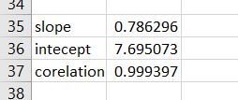

Slope= slope(TRUTH,FINAL)

Intercept=intercept(TRUTH,FINAL)

Corelation=correal(TRUTH,FINAL)

**Practical 9**

**Practical Name: Sending Raw data to the cloud**

**1)Explain the MQTT input and output node.**

Using protocol mqtt its is most popular and most used protocol in IOT.It works on publish subscribe model.It is located across the world and many non profit organizations used this protocol.It requires port 1883.The url of server is broker.hivemq.com.

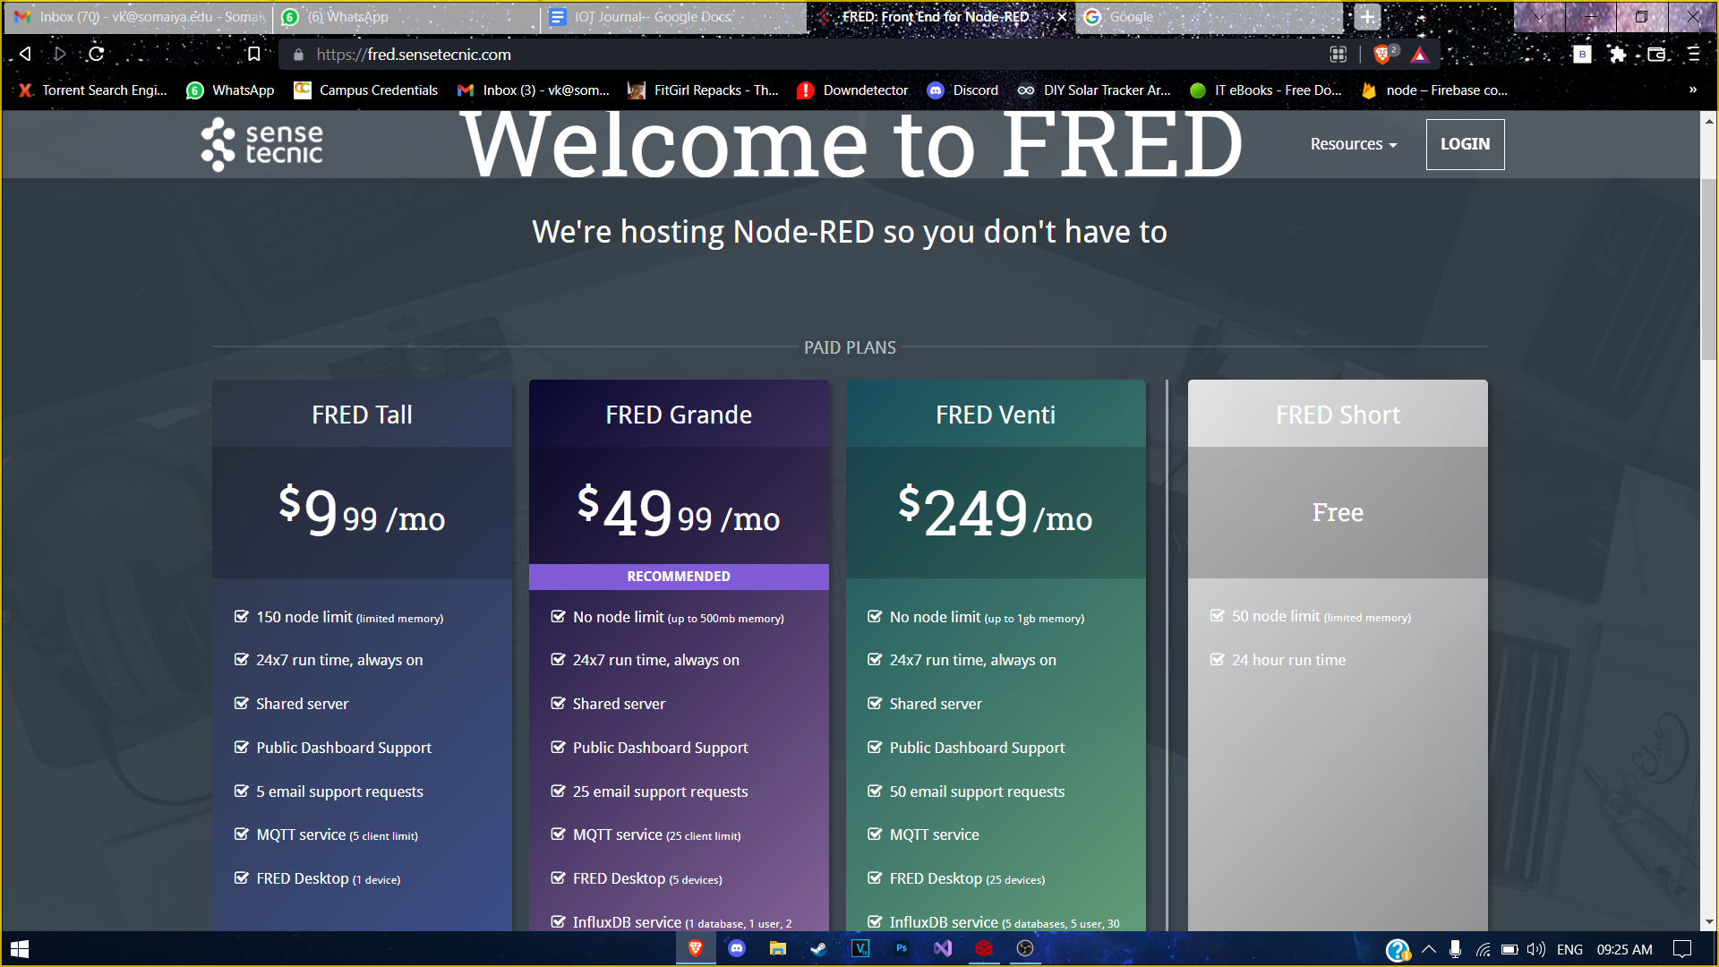

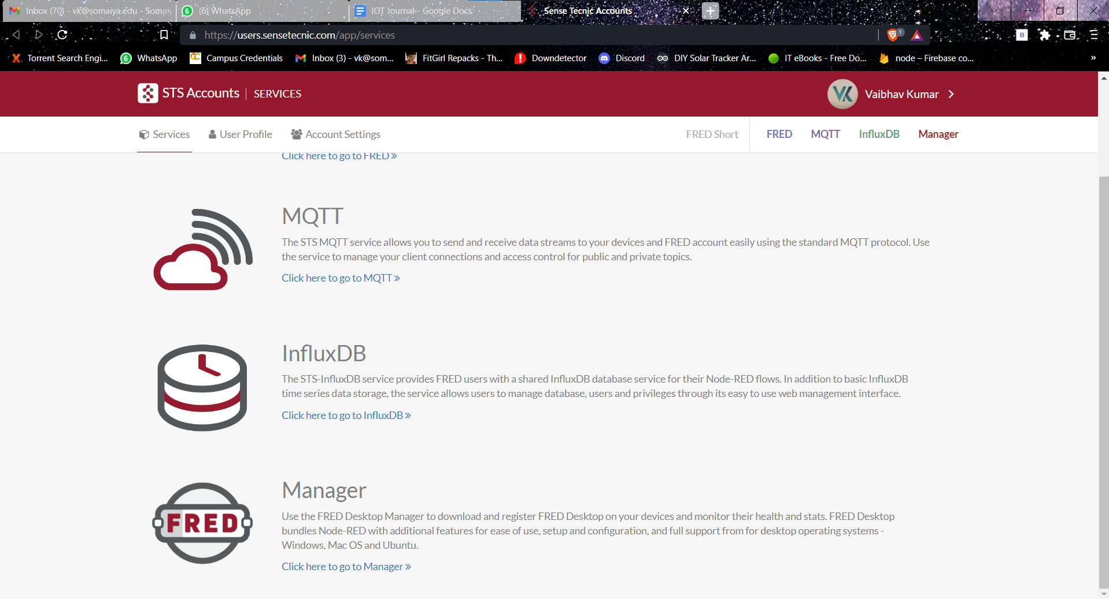

Click on to go to FRED

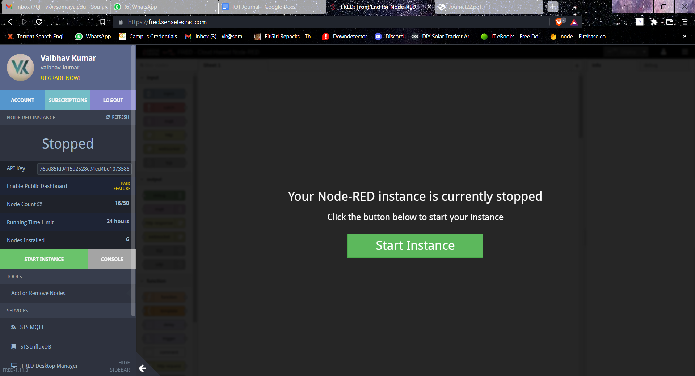

Click on start Instance and then create the empty flow

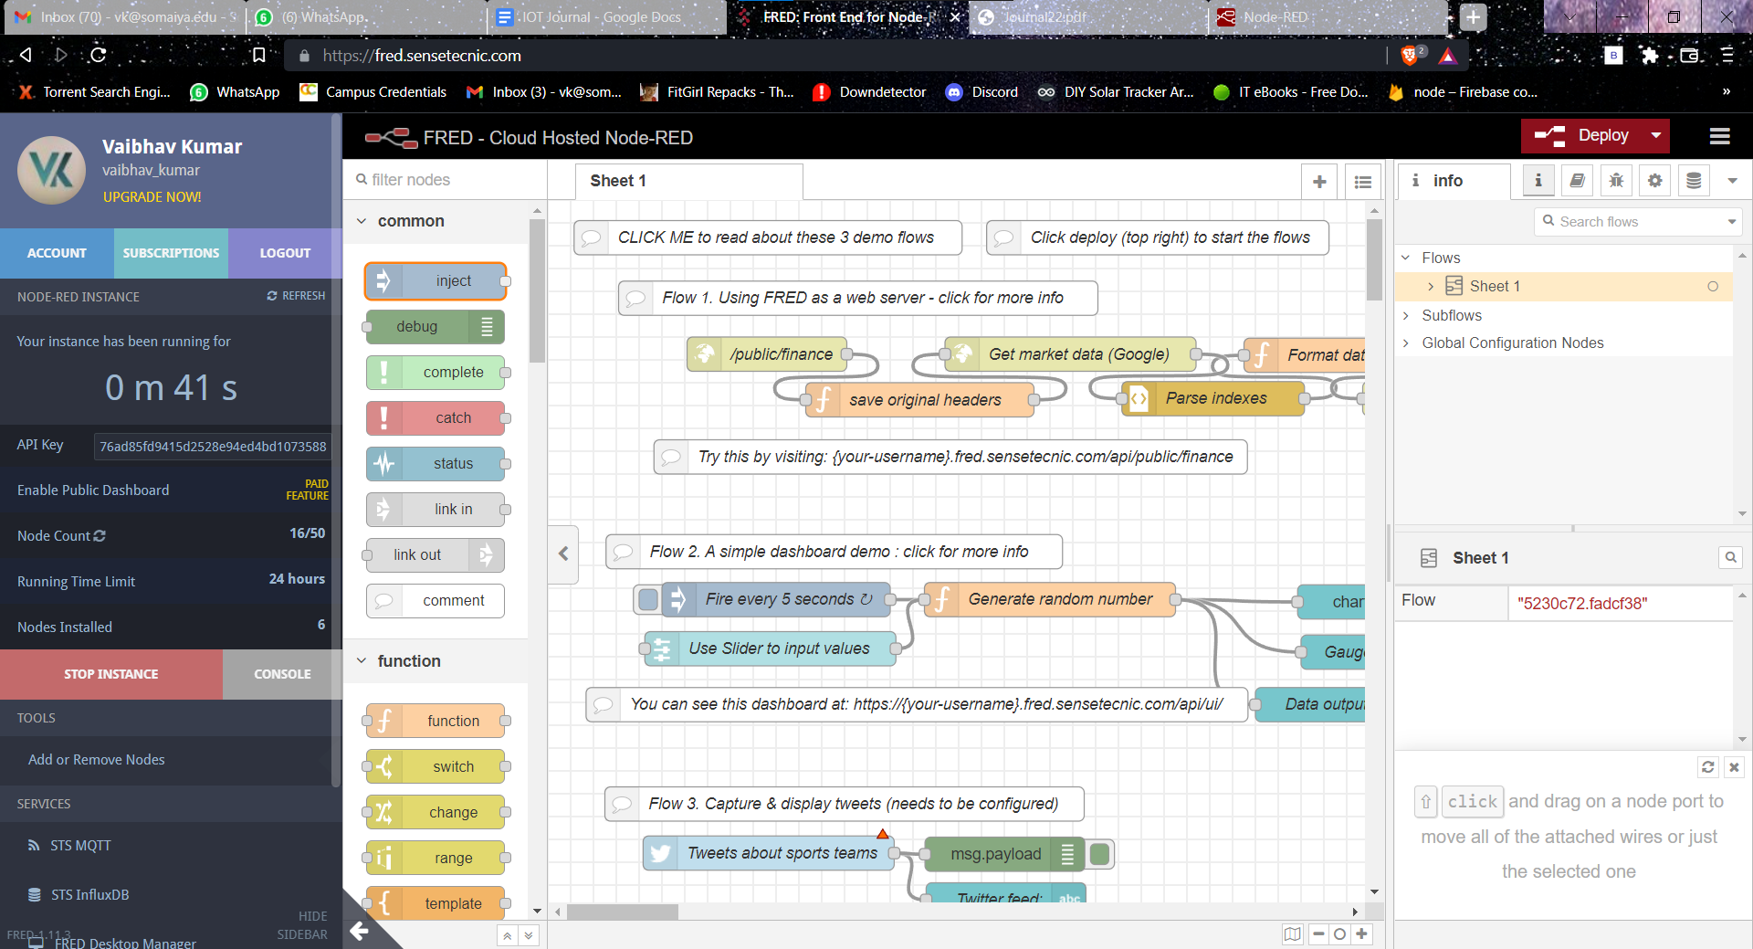

Now delete the sheet 1 by double clicking on sheet and click delete button

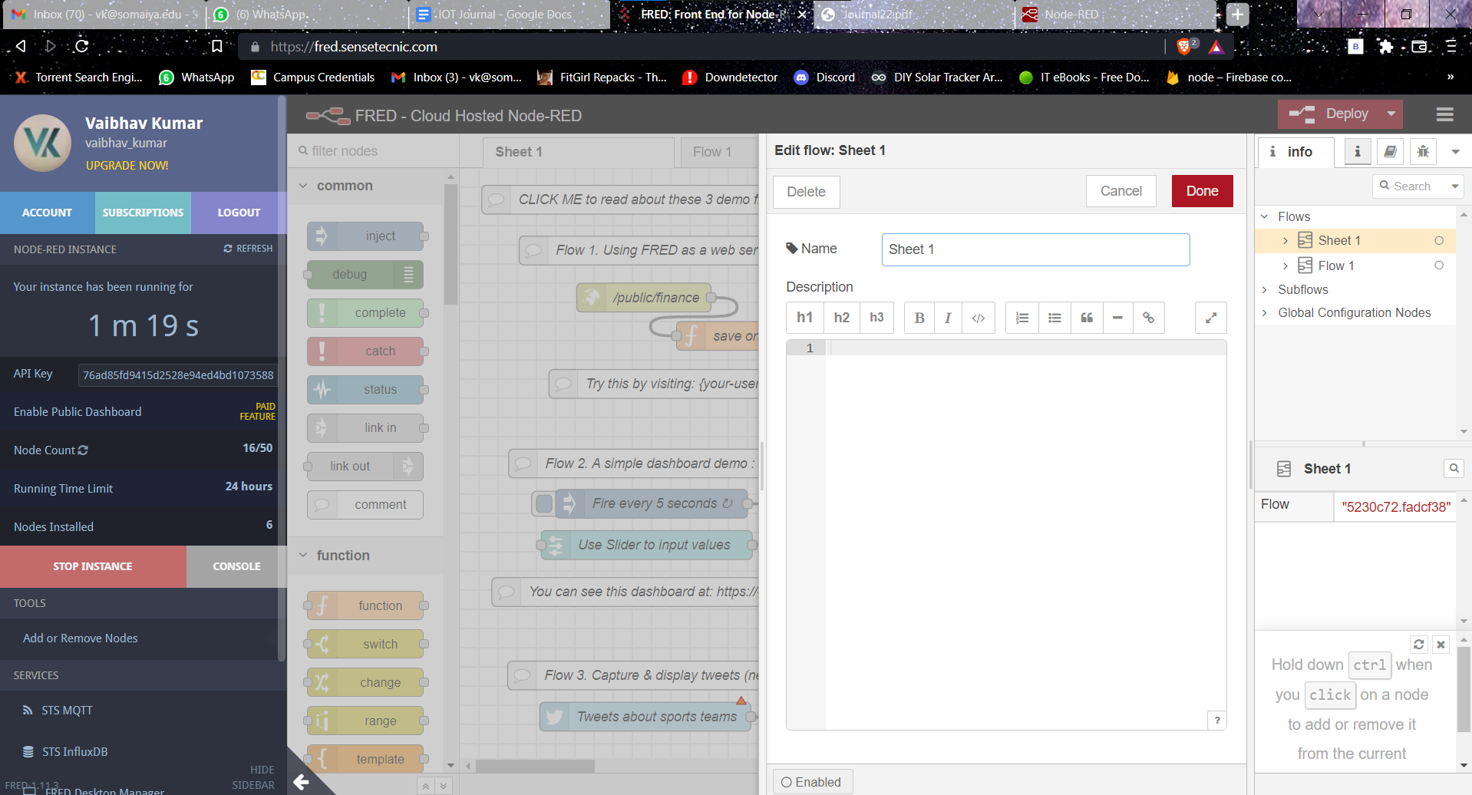

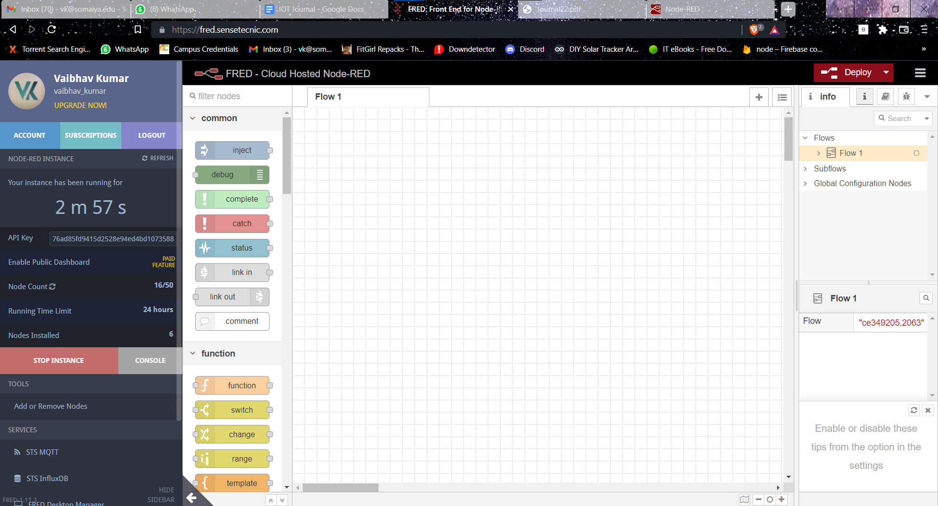

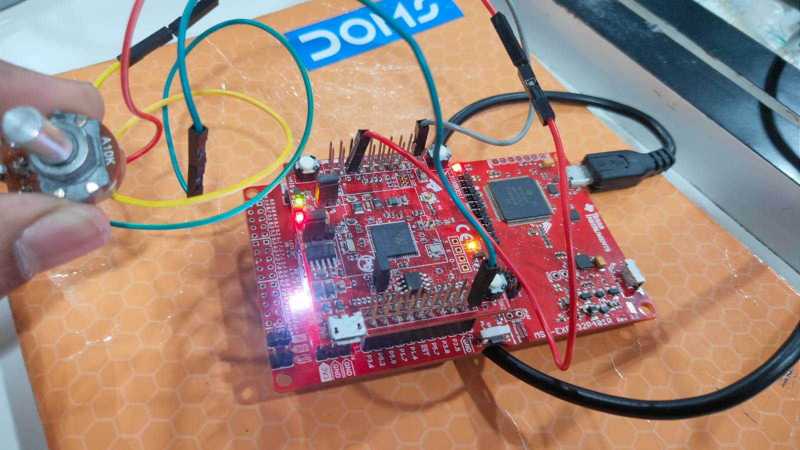

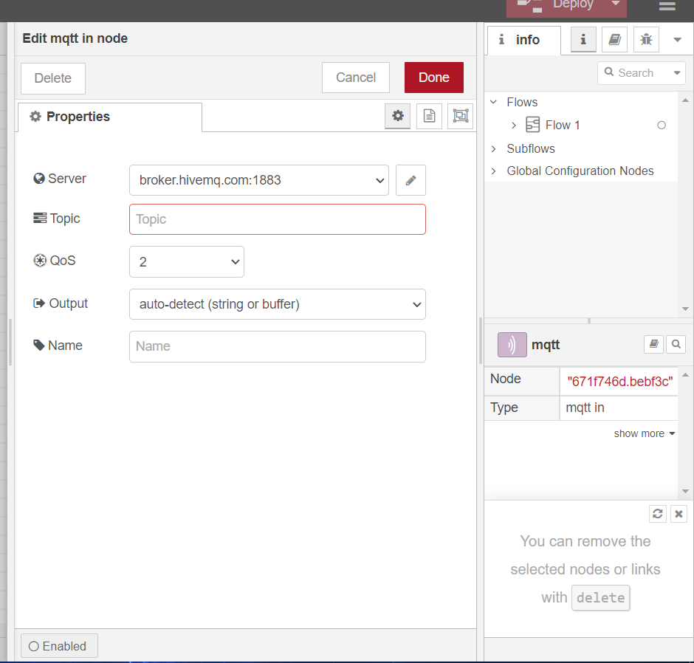

Click on pencil beside the Server

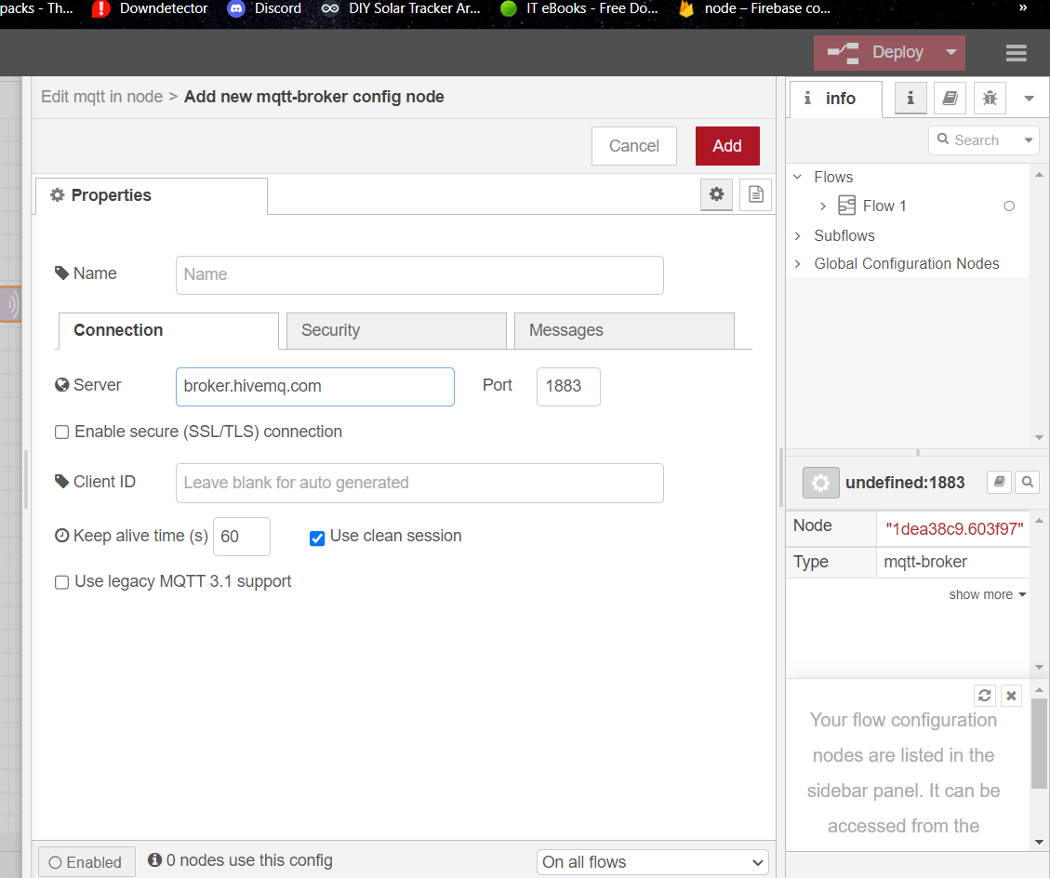

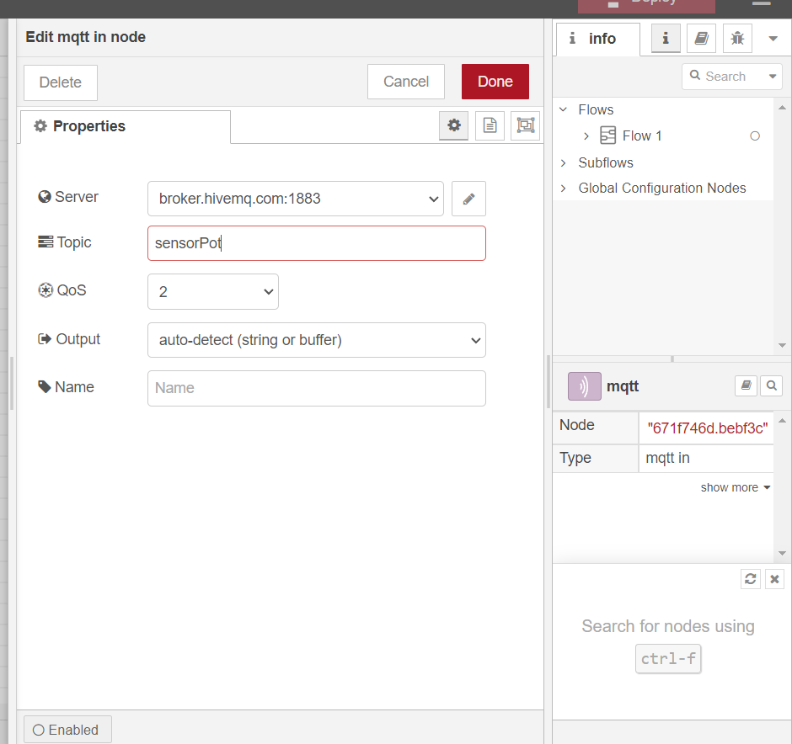

That sets the first node

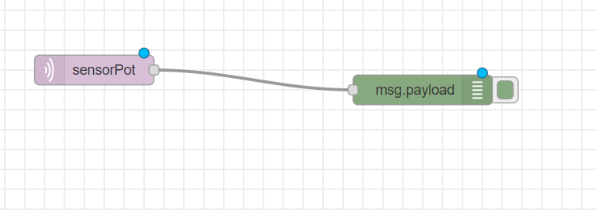

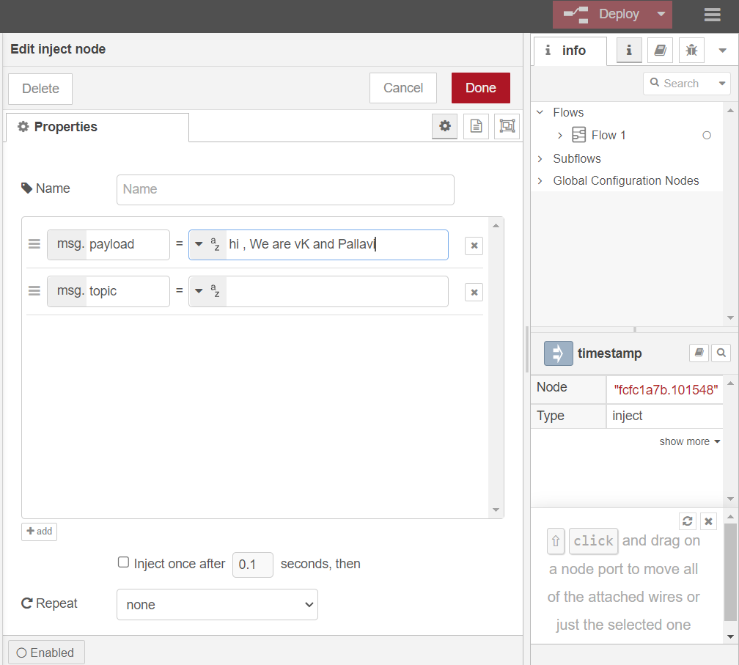

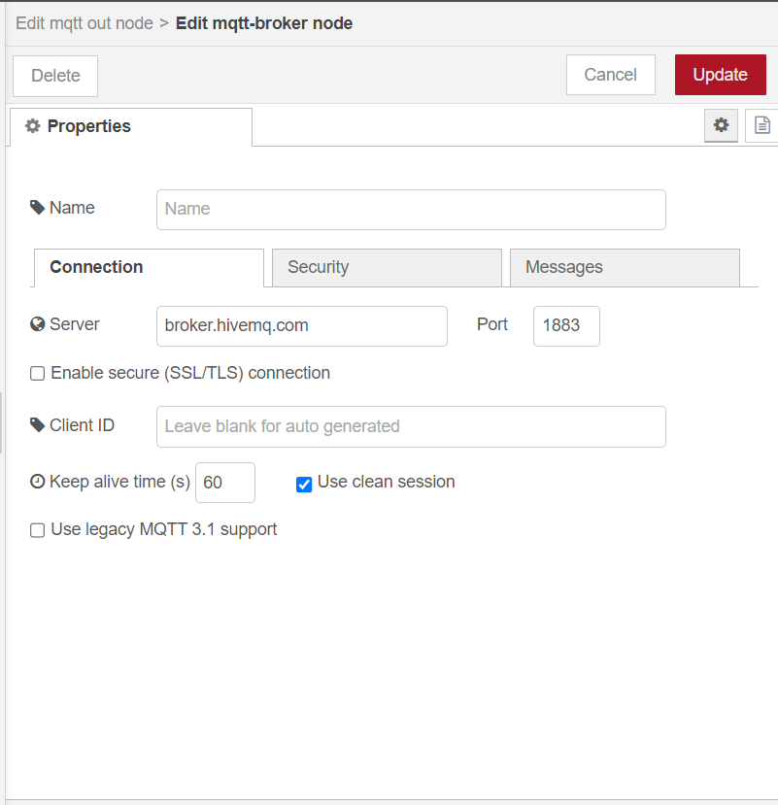

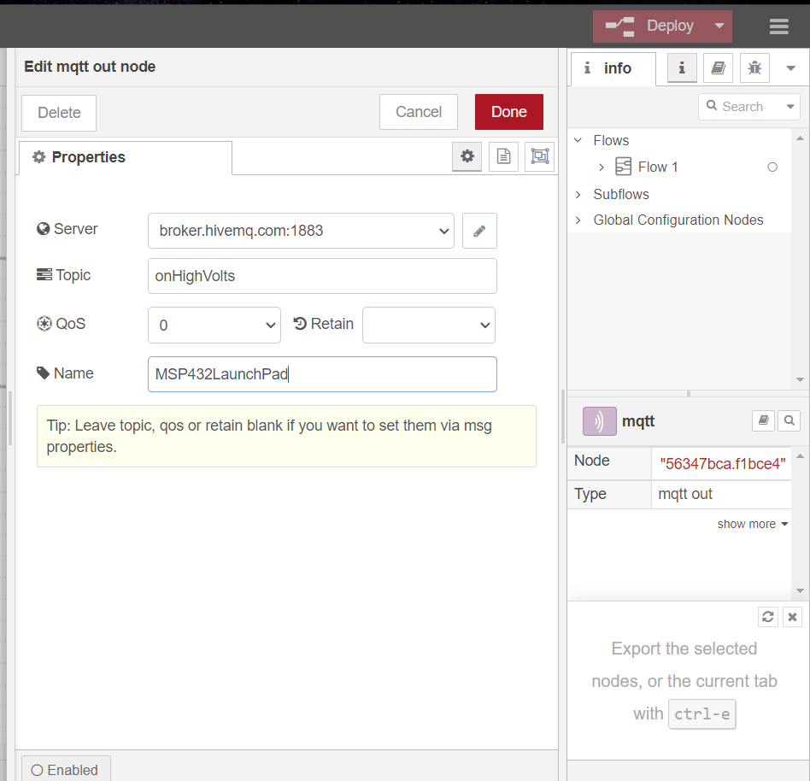

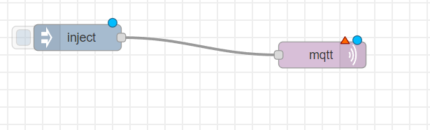

The one publishes on topic and the other one subscriber subscribe on the same topic.

Now deploy.

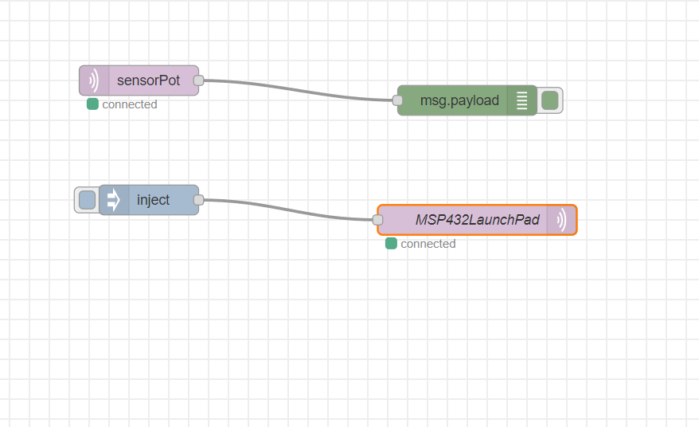

**2) Explain the JSON data frame created in the firmware.**

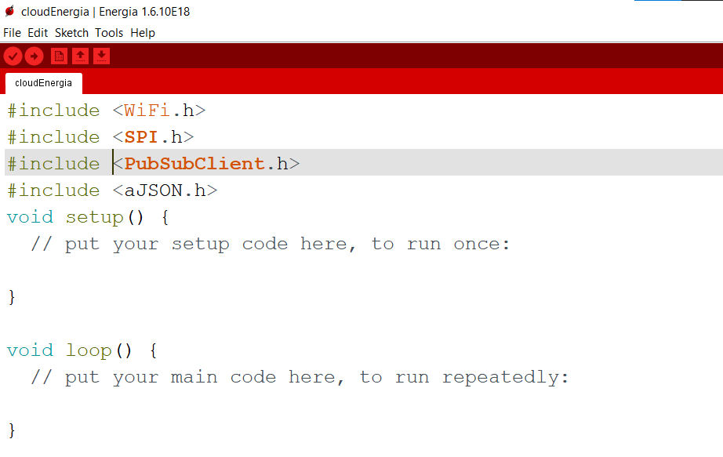

Create the project and first compile it empty without any code.

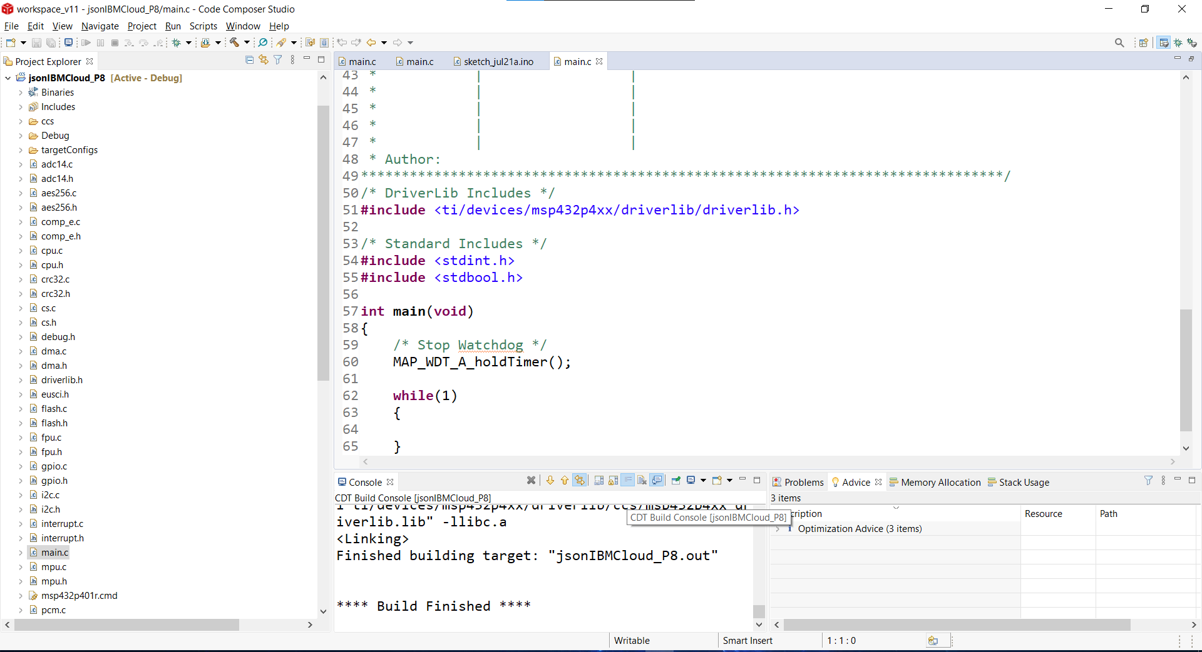

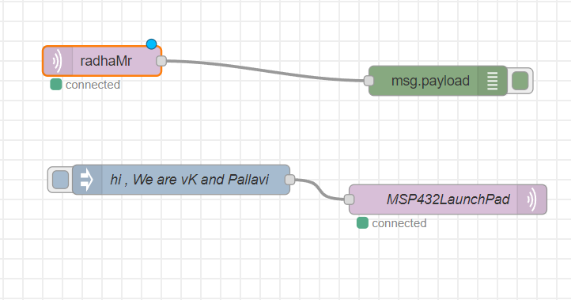

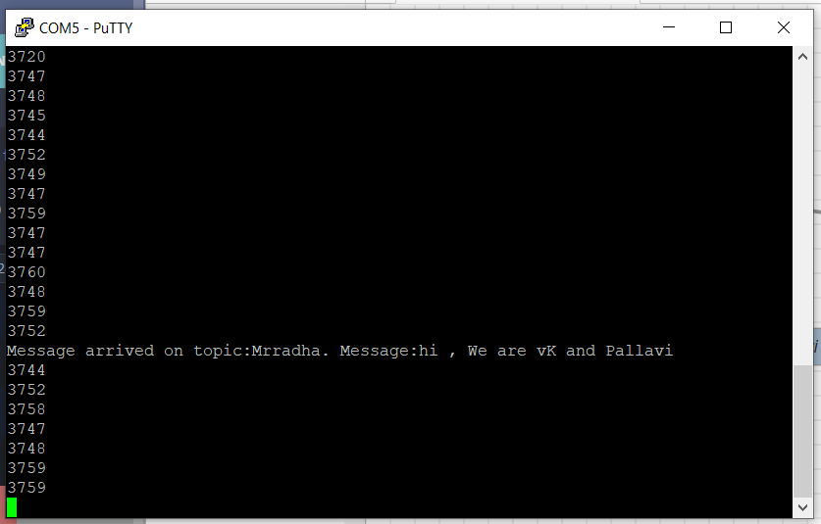

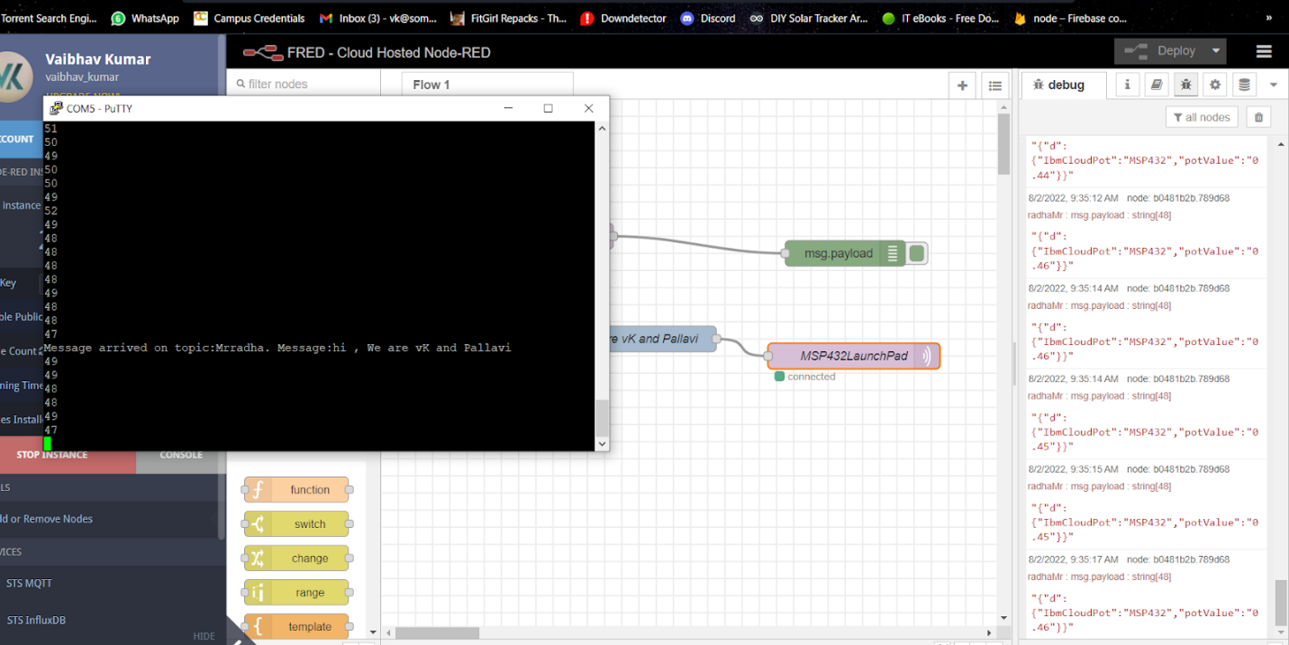

**Practical 10**

Connecting MSP432 to the cloud



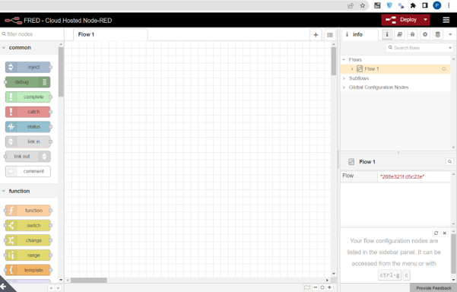

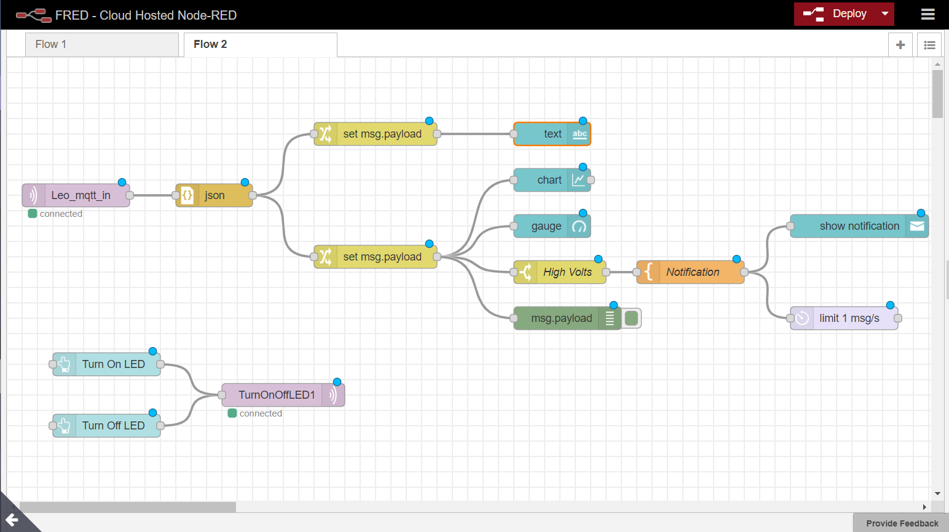

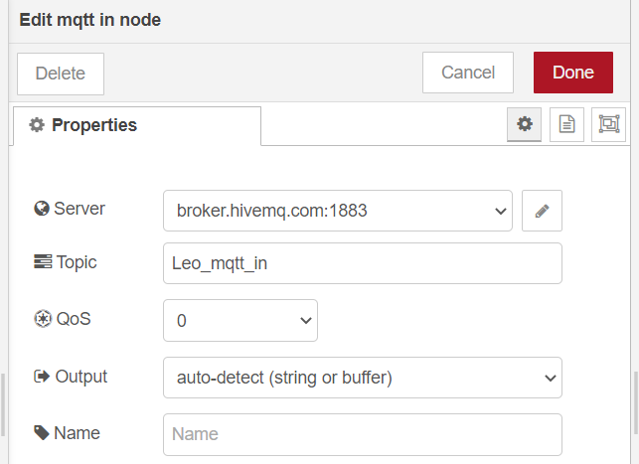

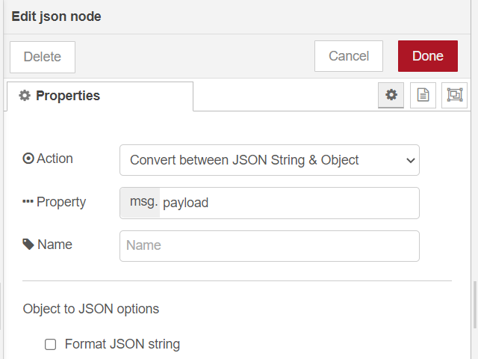

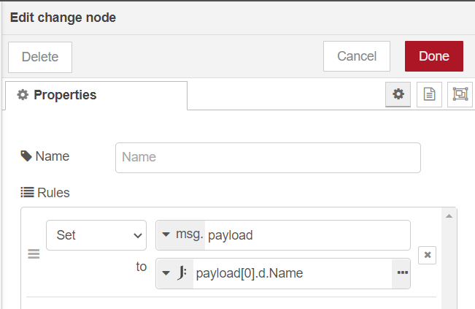

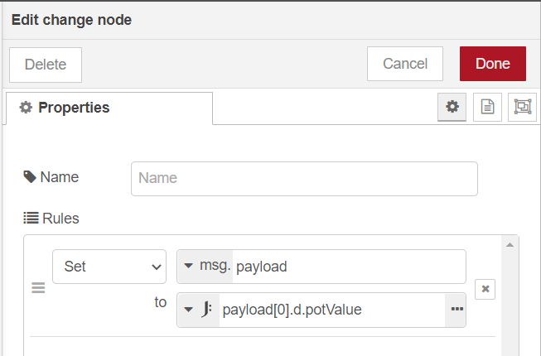

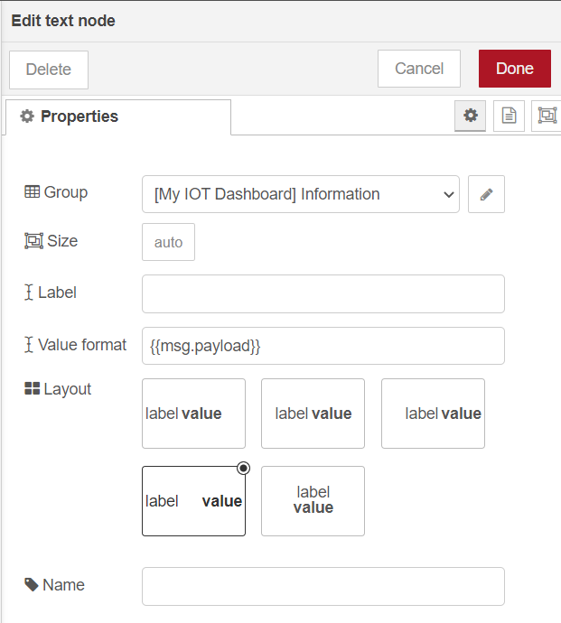

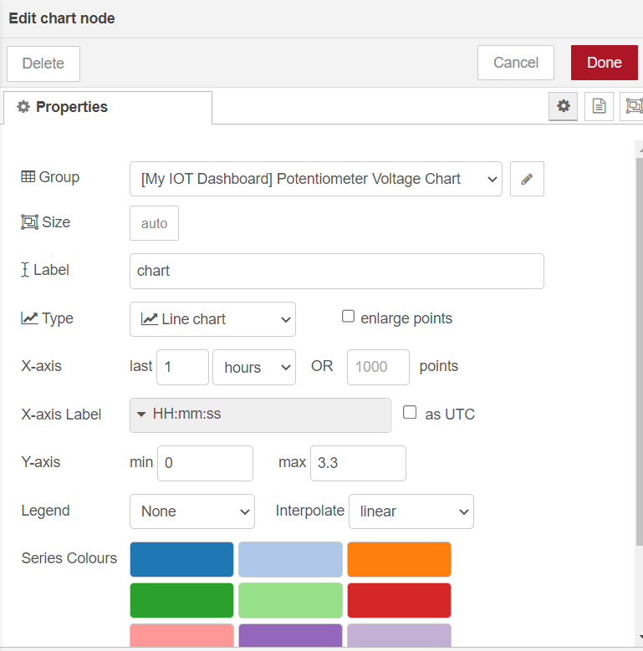

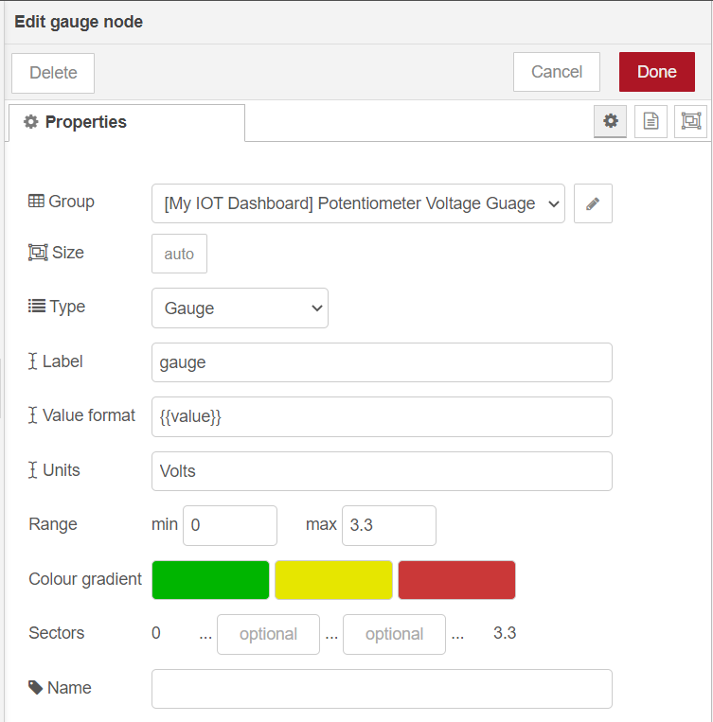

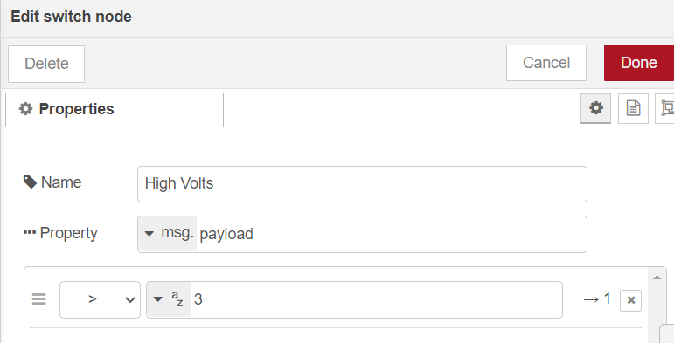

**CSSCODE**

#include <ti/devices/msp432p4xx/driverlib/driverlib.h>

#include <WiFi.h>

#include <SPI.h>

#include <PubSubClient.h>

#include <aJSON.h>

IPAddress shieldIP,subnetMask,gatewayIP;

uint8_t rssi;

uint8_t networkId;

byte macAddr[6];

byte encryptionType;

char ssid[]="Galaxy M21F8D8";

WiFiClient wclient;

char server[]="broker.hivemq.com";

PubSubClient client(server,1883,callback,wclient);

char* jsonPayload;

aJsonStream serial_stream(&Serial);

void setup() {

// put your setup code here, to run once:

Serial.begin(115200);

Serial.print("connecting to WIFI..");

while(WiFi.begin(ssid)!=WL_CONNECTED)//for cell phone //WL_CONNECTED while it is not connected

//while(WiFi.begin(ssid.password)!=WL_CONNECTED)

{

Serial.print(".");

delay(1);//delay in ms

}

Serial.println("");

Serial.print("Wifi Connected , Fetching Wifi Sheild's IP address :");

while(WiFi.localIP()==INADDR_NONE){

Serial.print(".");

delay(1);

}

shieldIP = WiFi.localIP();

Serial.println(shieldIP);

Serial.print("Access Point name:");

Serial.println(ssid);

Serial.print("Signal Strength");//

rssi=WiFi.RSSI();//it fecthes the signal strength

Serial.println(rssi); //RSSI-Recived signal strength indication

uint8_t networkId= WiFi.scanNetworks();

Serial.print("number of access points in range:");

Serial.println(networkId);

for(int i=1;i<=networkId;i++){

Serial.print("Name of Access points and encryption type:");

Serial.print(WiFi.SSID(i));

Serial.print(",");

encryptionType=WiFi.encryptionType(i);

Serial.println(encryptionType,HEX);

//Serial.println(encryptionType,DEC);

}

subnetMask = WiFi.subnetMask();

Serial.print("Subnet Mask:");

Serial.println(subnetMask);

gatewayIP=WiFi.gatewayIP();

Serial.print("Gateway IP Address:");

Serial.println(gatewayIP);

WiFi.macAddress(macAddr);

Serial.print("Mac Address of Sheild:");

for(int i=0;i<6;i++){

Serial.print(macAddr[i],HEX);

if(i<=4)

Serial.print(':');

else

Serial.println();

}

GPIO_setAsOutputPin(GPIO_PORT_P1,GPIO_PIN0);

GPIO_setAsOutputPin(GPIO_PORT_P2,GPIO_PIN0|GPIO_PIN1|GPIO_PIN2);

GPIO_setAsPeripheralModuleFunctionInputPin(GPIO_PORT_P4,GPIO_PIN7,GPIO_TERTIARY_MODULE_FUNCTION);//potentiometer is connect in port 4 ,

//pin 7 becoz ADC exists in PIN 7 of port 4 and then digital signal goes to LED

ADC14_initModule(ADC_CLOCKSOURCE_MCLK,ADC_PREDIVIDER_1,ADC_PREDIVIDER_1,ADC_NOROUTE);//initModule requires 4 parameters//clock is started //predivider is divding the clock to make it small//master clock is 3 MHz which is divider by 2 divders // ADC Noroute means use ADC to connect to that pin // more the predivider more the numbers we can get

ADC14_configureSingleSampleMode(ADC_MEM6,true);//ADC_MEM6 internal memory for storing converted result

ADC14_configureConversionMemory(ADC_MEM6,ADC_VREFPOS_AVCC_VREFNEG_VSS,ADC_INPUT_A6,false);//2nd parameter is 3.3v i.e the refrences voltage , 3rd para is use that channel 6 inside MC and store it to the mem 6 , false is it will run only once

ADC14_setSampleHoldTime(ADC_PULSE_WIDTH_32,ADC_PULSE_WIDTH_4);//it will hold the signal for 64 clock cycle , 2 times becoz it require 2 parameter ; our MC is 32bit so it divided into 16-16 bits channels 2nd para is useless as of now

ADC14_setResolution(ADC_12BIT);

ADC14_enableSampleTimer(ADC_AUTOMATIC_ITERATION);//it will run automatically

ADC14_enableModule();//for activating the module

ADC14_enableConversion();//start conversion

ADC14_toggleConversionTrigger();// trigger the conversion again and again

}

void loop() {

// put your main code here, to run repeatedly:

if(!client.connected())

{

Serial.println("Disconnected:Reconnecting...");

if(!client.connect("sagarPraful"))

{

Serial.println("connection failed");

}

else

{

Serial.println("Connection success");

if(client.subscribe("prafulNalanda"))

{

Serial.println("Subscription sucessfull");

}

}

}

int result,regressedData1;

float regressedData;

while(!ADC14_isBusy());

result=ADC14_getResult(ADC_MEM6);

//P2OUT=result>>8;

//Serial.println(result);

ADC14_toggleConversionTrigger();

//result*slope+-itercept/1000

regressedData=((result*0.786295966)+7.695073417)/1000;

Serial.println(regressedData);

regressedData1=((result*0.786295966)+7.695073417);

P2->OUT = result>>8;

String str=(String)regressedData1;

int str_len=str.length()+2;

char char_array[str_len];

str.toCharArray(char_array,str_len);

char pot_reading[str_len];

if(regressedData<1)

{

pot_reading[0]='0';

pot_reading[1]='.';

for(int i=2;i<=str_len;i++)

{

pot_reading[i]=char_array[i-2];

}

}

else

{

pot_reading[0]=char_array[0];

pot_reading[1]='.';

for(int i=2;i<=str_len;i++)

{

pot_reading[i]=char_array[i-1];

}

}

aJsonObject *root=aJson.createObject();

aJsonObject *d=aJson.createObject();

aJson.addItemToObject(root,"d",d);

aJson.addStringToObject(d,"IbmCloudPot","MSP432");

aJson.addStringToObject(d,"potValue",pot_reading);

jsonPayload=aJson.print(root)+'\0';//renders the jso object back to a string;

aJson.deleteItem(d);

aJson.deleteItem(root);

//publish data to MQTT broker

client.publish("nalandaPraful",jsonPayload);

client.poll();

delay(1000);

}

void callback(char* inTopic,byte* payload,unsigned int length)

{

Serial.print("Message arrived on topic:");

Serial.print(inTopic);

Serial.print(". Message:");

String arrivedMessage;

for(int i=0;i<length;i++)

{

Serial.print((char)(payload[i]));

arrivedMessage+=(char)payload[i];

}

Serial.println();

if(arrivedMessage=="LED1ON")

GPIO_setOutputHighOnPin(GPIO_PORT_P1,GPIO_PIN0);

else

if(arrivedMessage=="LED1OFF")

GPIO_setOutputLowOnPin(GPIO_PORT_P1,GPIO_PIN0);

}

**OUTPUT :**

